Week 1

Primer on Machine Learning

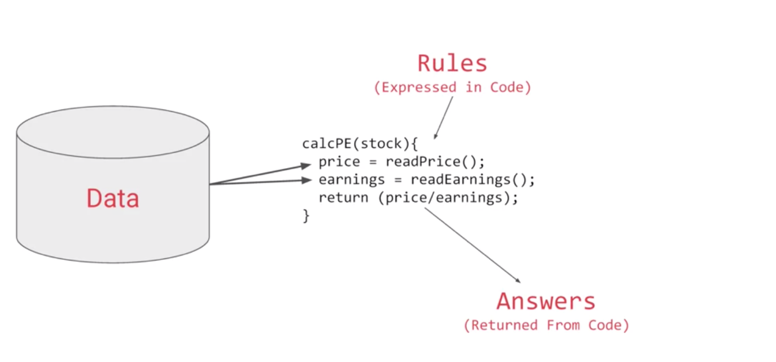

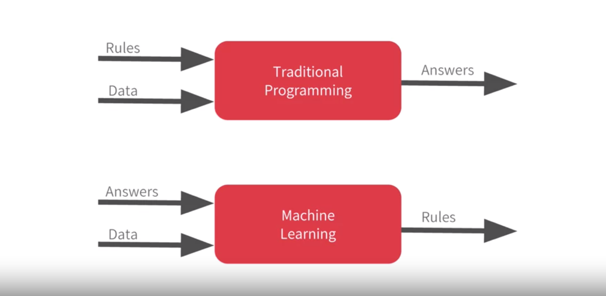

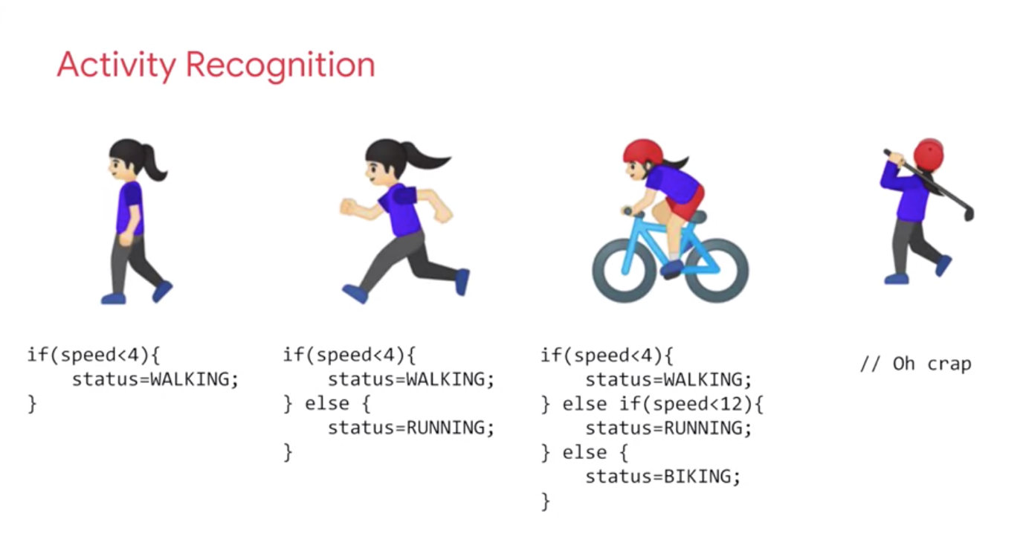

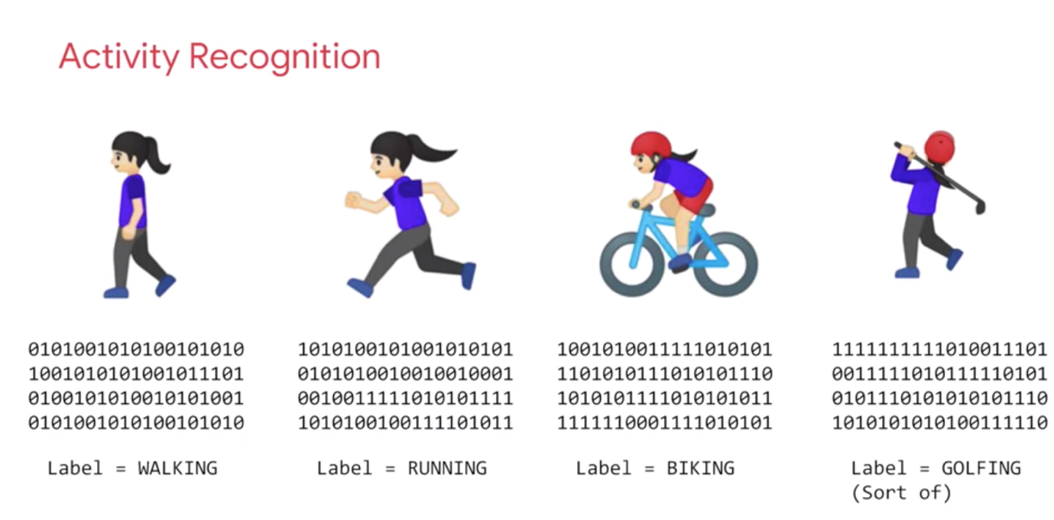

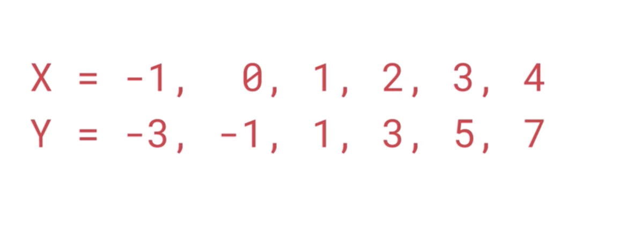

Keras:

* make it easy to define neural networks
* Dense: to define a layer of connected neurons
* Successive layers are defined in sequence
* Loss function : the neural net has no idea about the relationship between X and Y and so it guesses => loss function measures how far off the guesses are, then feed it to Optimizer which figures out the next step => each guess should be better than the one before => as the guess get better and better and accuracy approaches 100% => convergence is achieved
* Optimizer (sgd = stochastic gradient descent)
* Training takes place in fit command; epoch = training loop when the model guesses => deals with result in probability

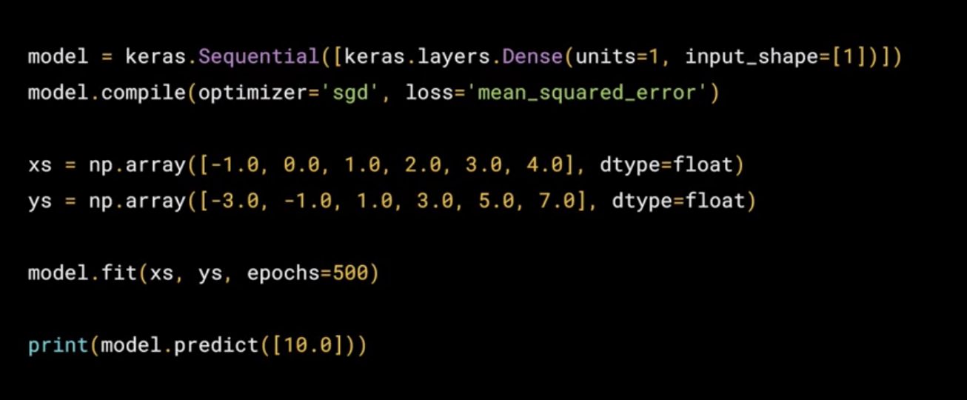

WEEK 2: COMPUTER VISION

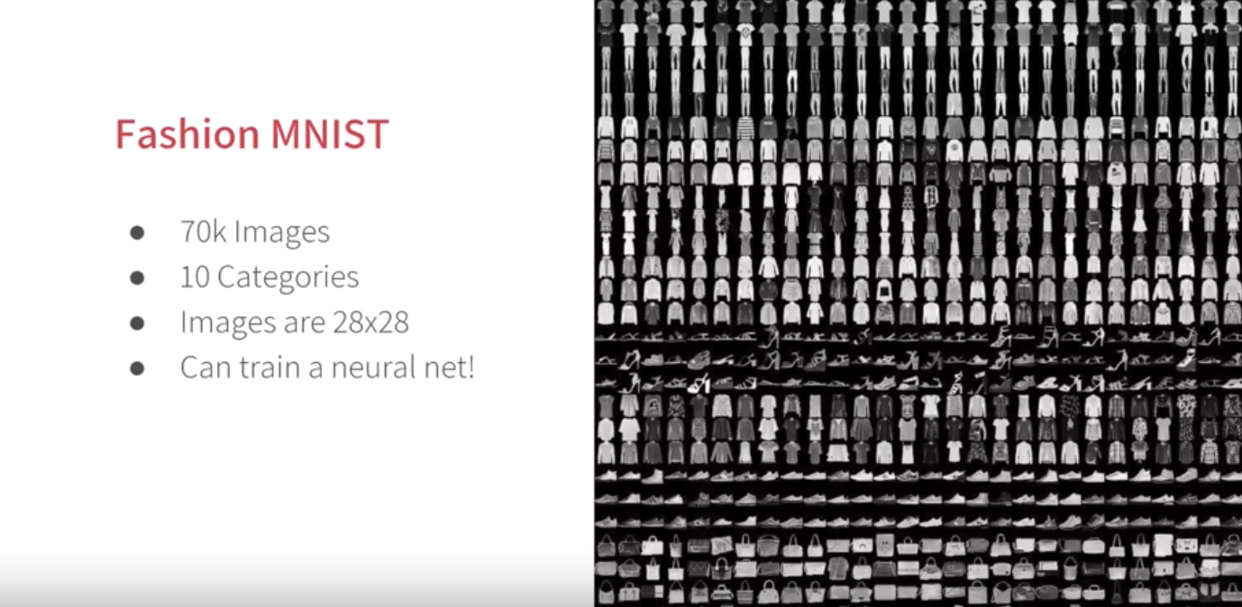

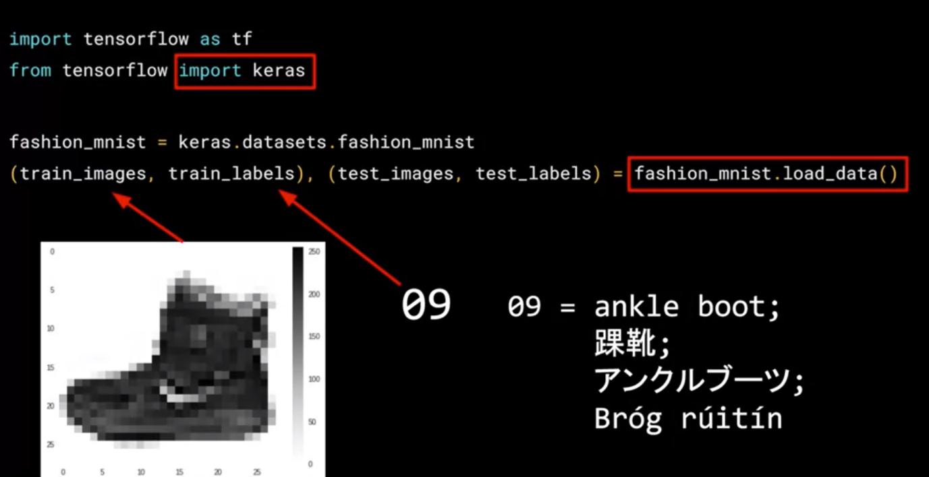

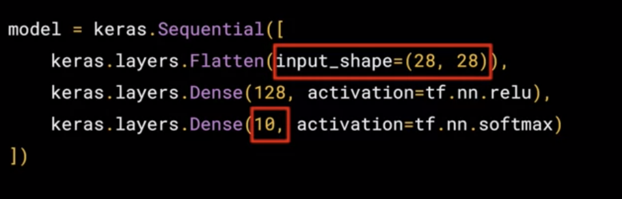

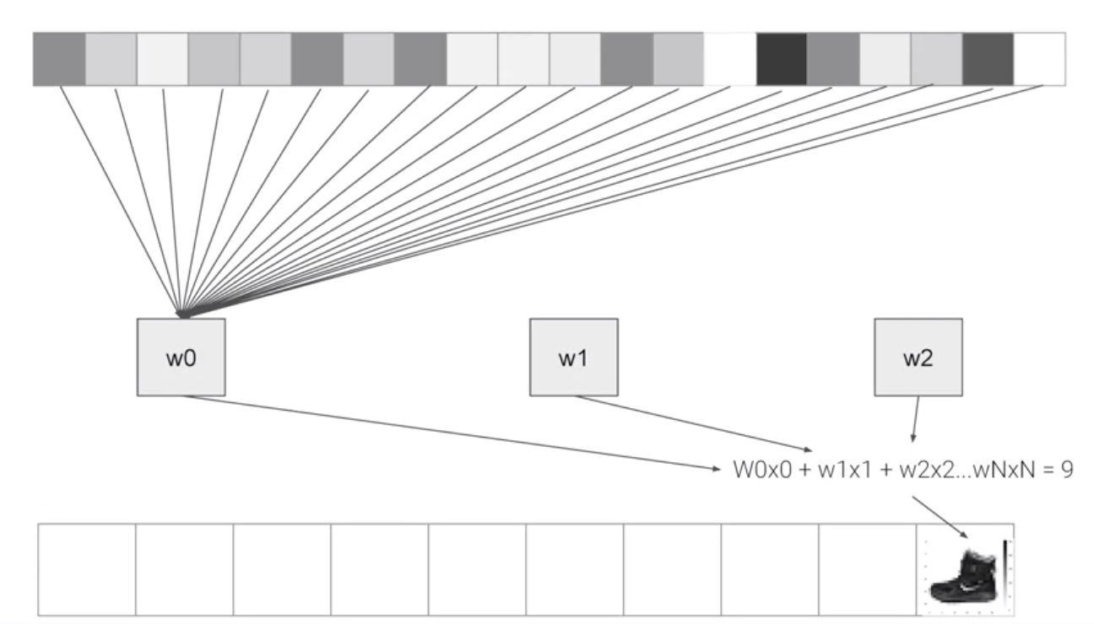

Using callbacks to control training

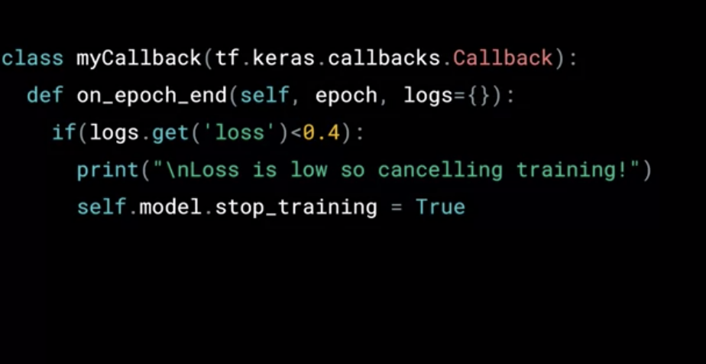

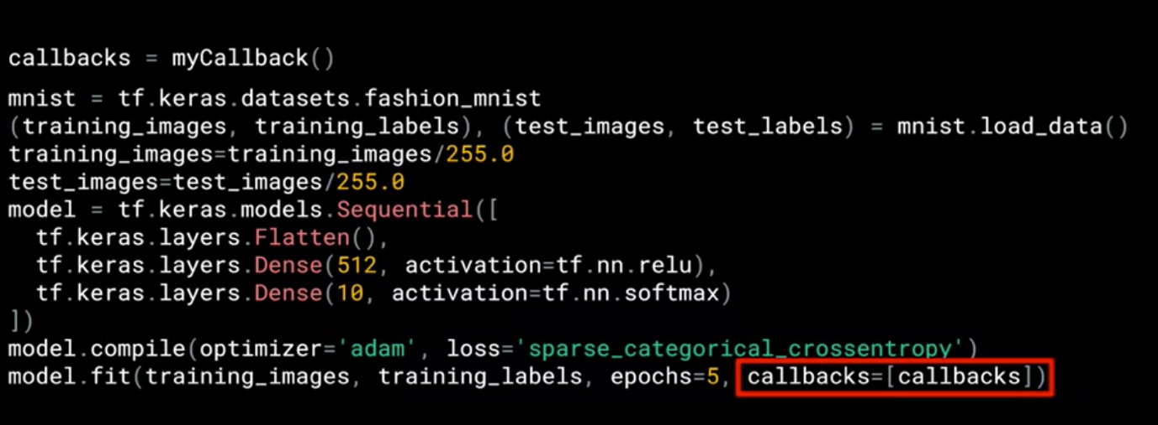

Week 3 – Enhancing Computer Vision with CNN

* Convolution: a filter to process the image. Some convolution will alter the image in a way that underscore its prominent features
* Pooling: a way of compressing an image: preserving the features found by convolution while also decreasing the size of the image

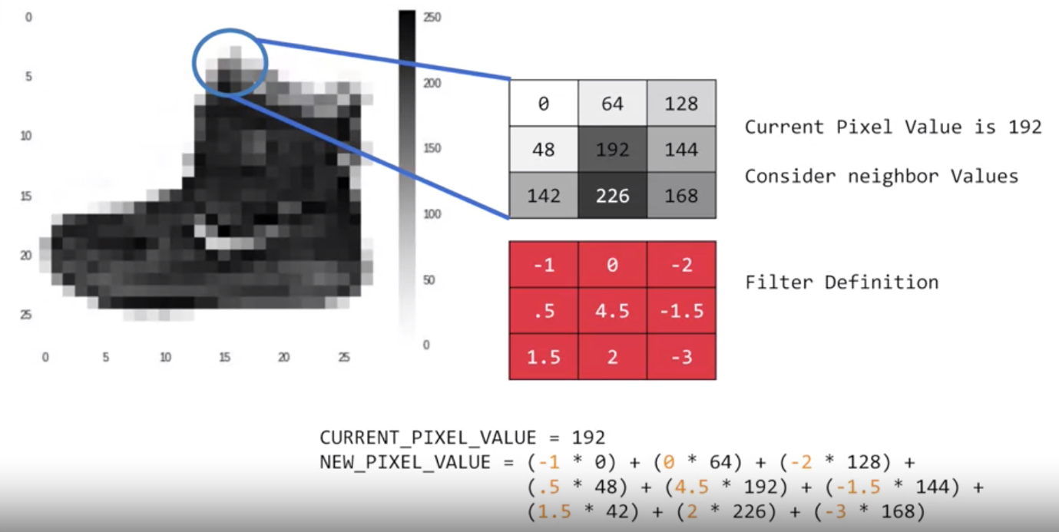

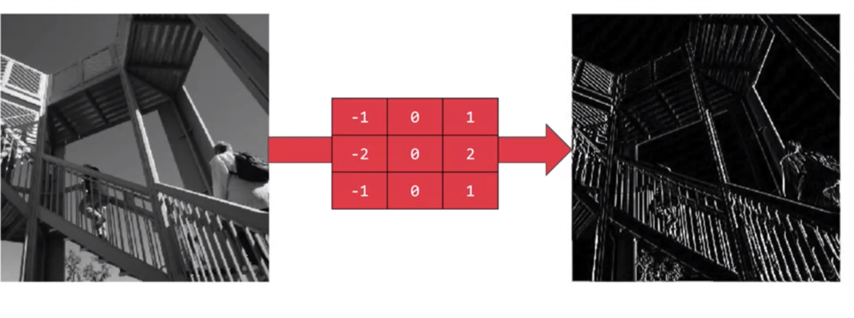

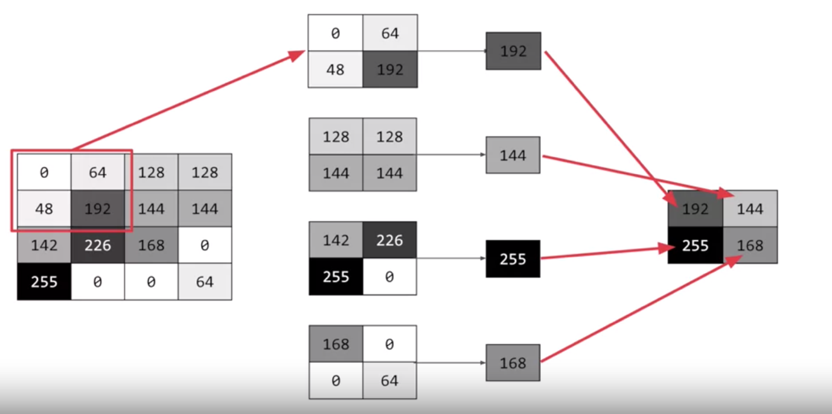

Code:

* Ask keras to generate 64 filters of size 3x3, activation relu (negative values will be thrown away) and input shape as before 28x28, extra 1 = we’re using a single byte for color depth
* 64: start with a set of known good filters
* Model.summary(): allow you to inspect the layers of the model , output a nice table with details about the layers and the output shape

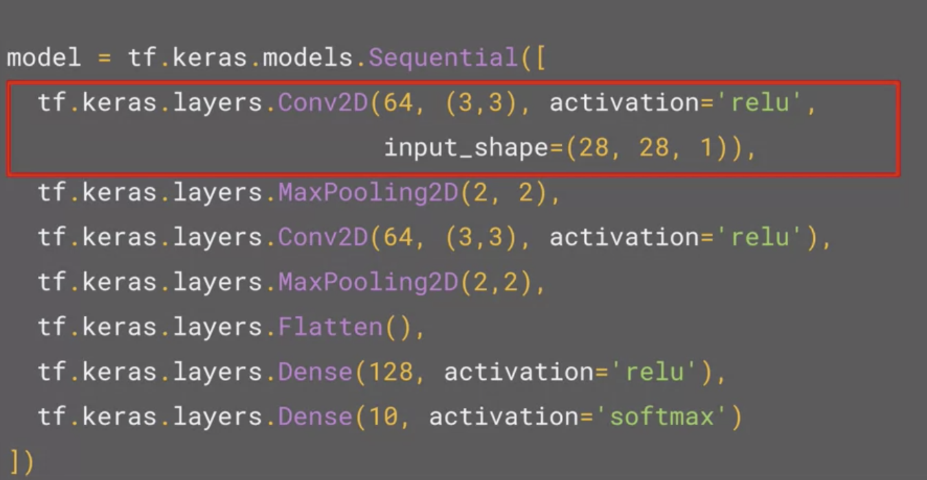

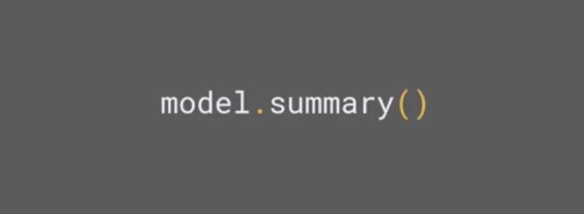

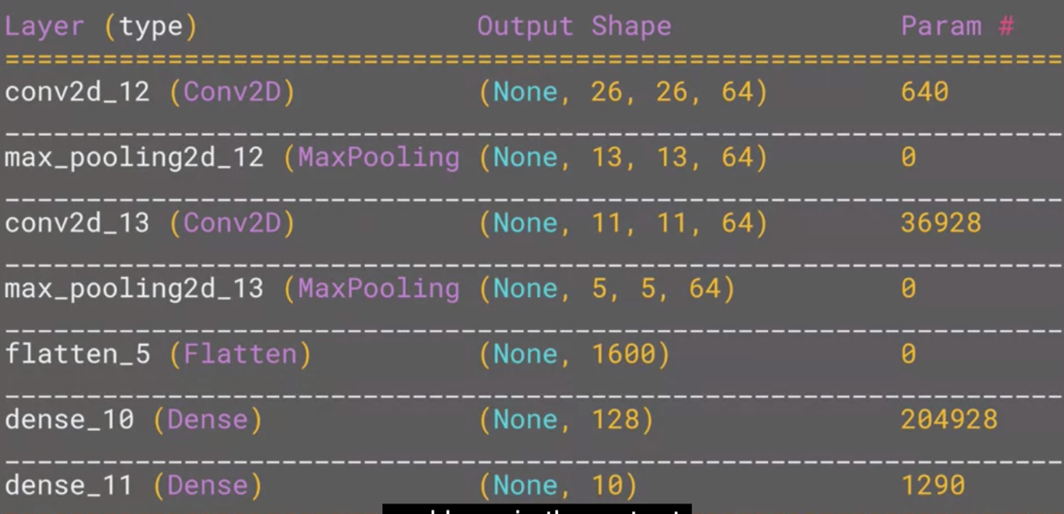

Week 4 – Complex images

Images that are used for practice are staged and uniform, whereas images in real life are rarely so

* Features might be in different locations (hard to crop en-mass)
* ImageGenerator: automatically create training and test set

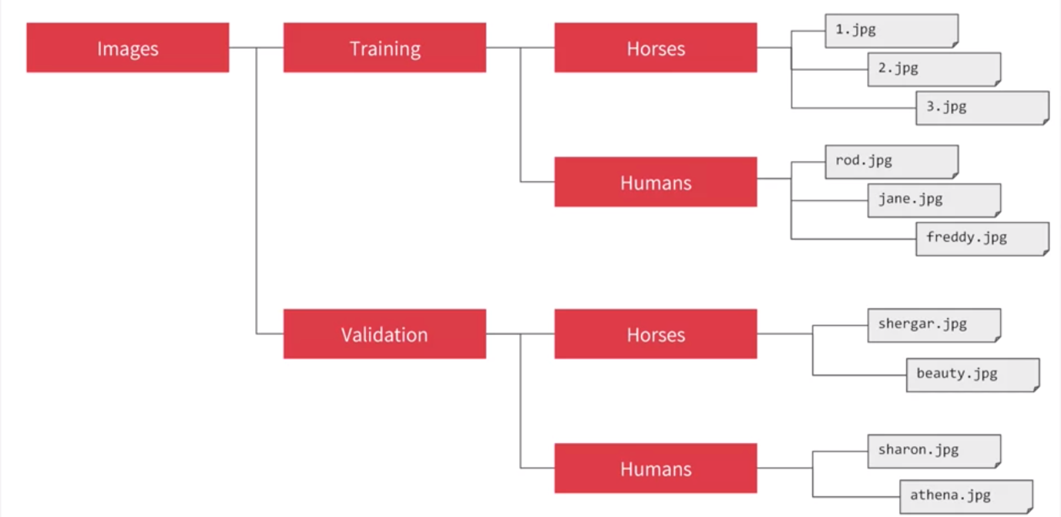

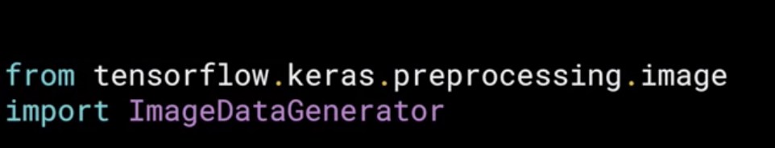

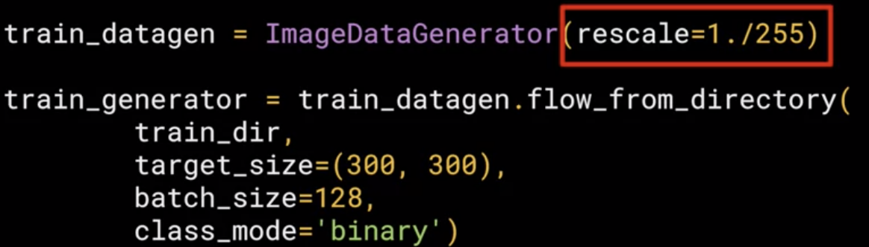

CNN architecture for complex images

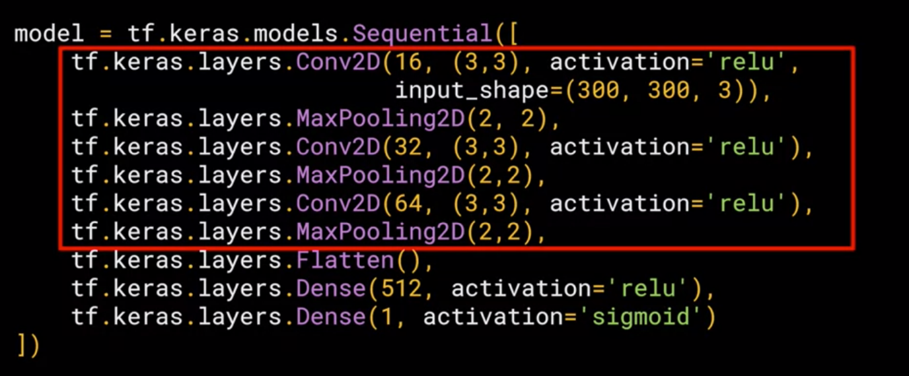

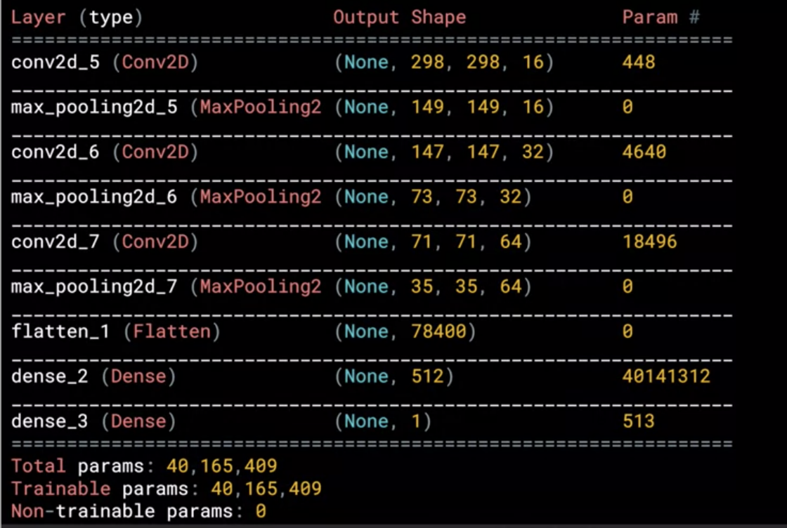

Train ImageGenerator

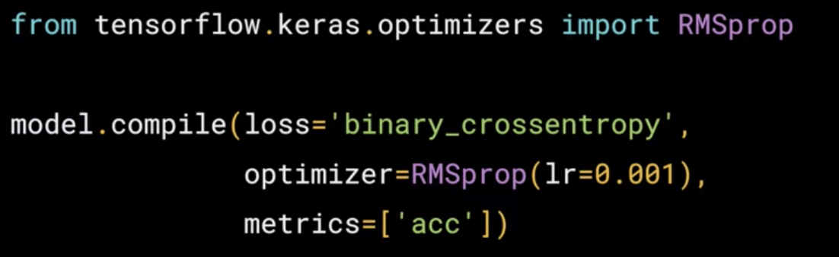

Use RMSprop to adjust learning rate

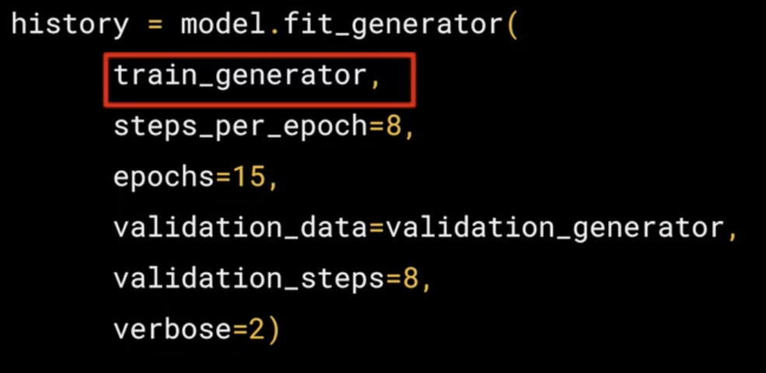

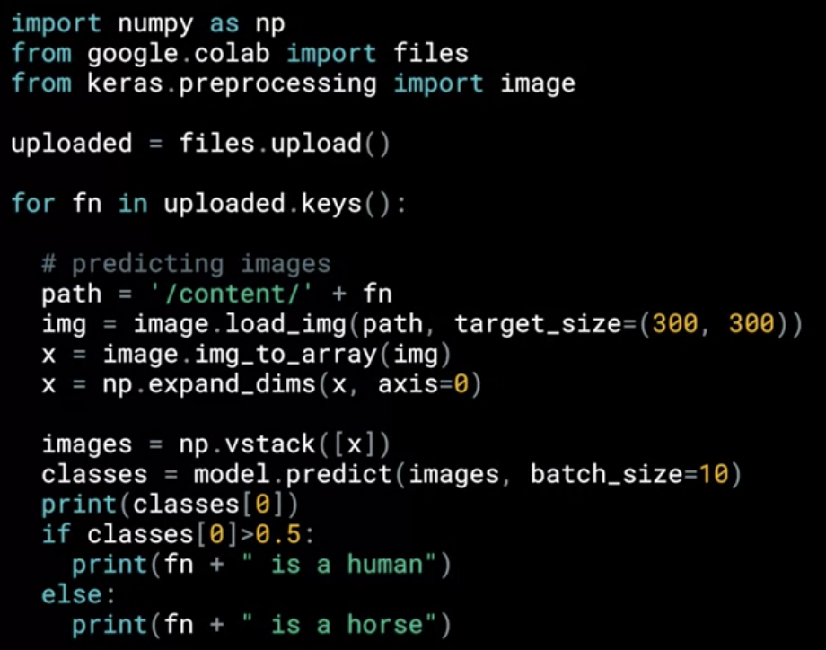

COURSE 2 – CONVOLUTIONAL NEURAL NETWORKS IN TENSORFLOW

Week 2 – Image and Data Augmentation

* Helps increase dataset and your neural network perform better
* Load images into memory, process the images and then stream that to the training set in neural network
* Image Augmentation is a very simple, but very powerful tool to help you avoid overfitting your data. The concept is very simple though: If you have limited data, then the chances of you having data to match potential future predictions is also limited, and logically, the less data you have, the less chance you have of getting accurate predictions for data that your model hasn't yet seen. To put it simply, if you are training a model to spot cats, and your model has never seen what a cat looks like when lying down, it might not recognize that in future.
* Augmentation simply amends your images on-the-fly while training using transforms like rotation. So, it could 'simulate' an image of a cat lying down by rotating a 'standing' cat by 90 degrees. As such you get a cheap way of extending your dataset beyond what you have already.
* To learn more about Augmentation, and the available transforms, check out <https://github.com/keras-team/keras-preprocessing>-- and note that it's referred to as *pre*processing for a very powerful reason: that it doesn't require you to edit your raw images, nor does it amend them for you on-disk. It does it in-memory as it's performing the training, allowing you to experiment without impacting your dataset.

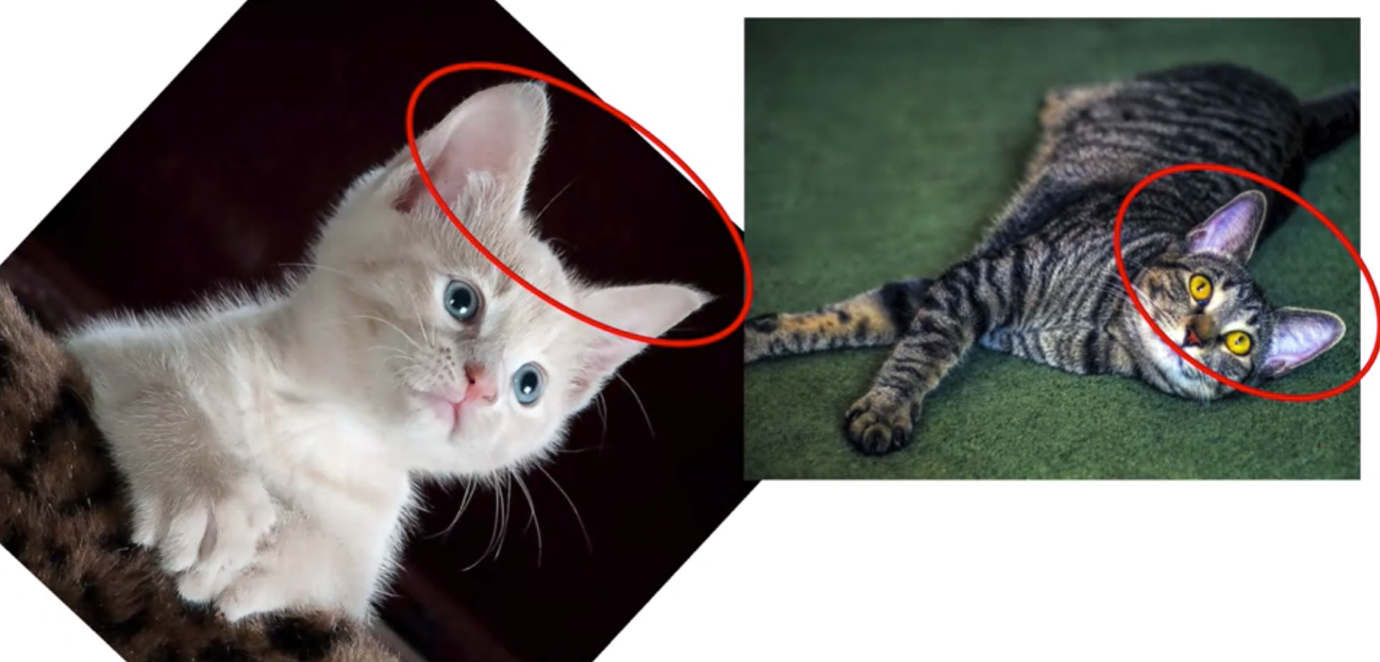

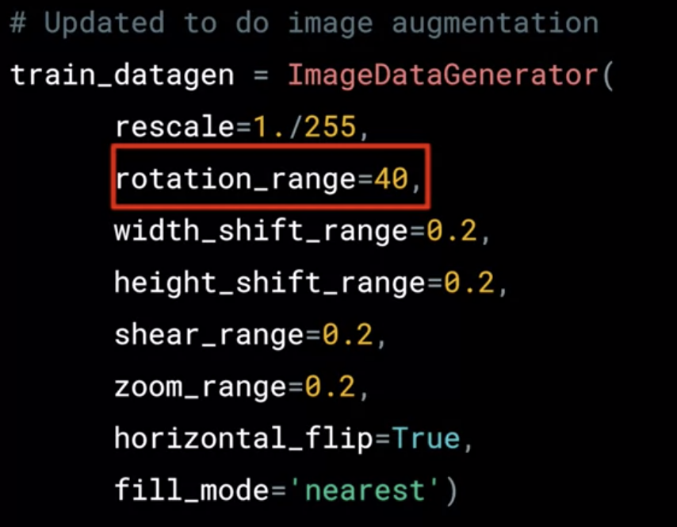

Image augmentation can introduce randomness to training dataset but if validation set doesn’t have the same randomness then it doesn’t improve the model significantly.

* Need a broad set of diverse images for both training and testing

WEEK 3 – TRANSFER LEARNING

Using a pre-trained model for **feature extraction** - when working with a small dataset, it is common to leverage the features learned by a model trained on a larger dataset in the same domain. This is done by instantiating the pre-trained model and adding a fully connected classifier on top. The pre-trained model is "frozen" and only the weights of the classifier are updated during training. In this case, the convolutional base extracts all the features associated with each image and we train a classifier that determines, given these set of features to which class it belongs. * **Fine-tuning** a pre-trained model - to further improve performance, one might want to repurpose the top-level layers of the pre-trained models to the new dataset via fine-tuning. In this case, we tune our weights such that we learn highly specified and high level features specific to our dataset. This only make sense when the training dataset is large and very similar to the original dataset that the pre-trained model was trained on.

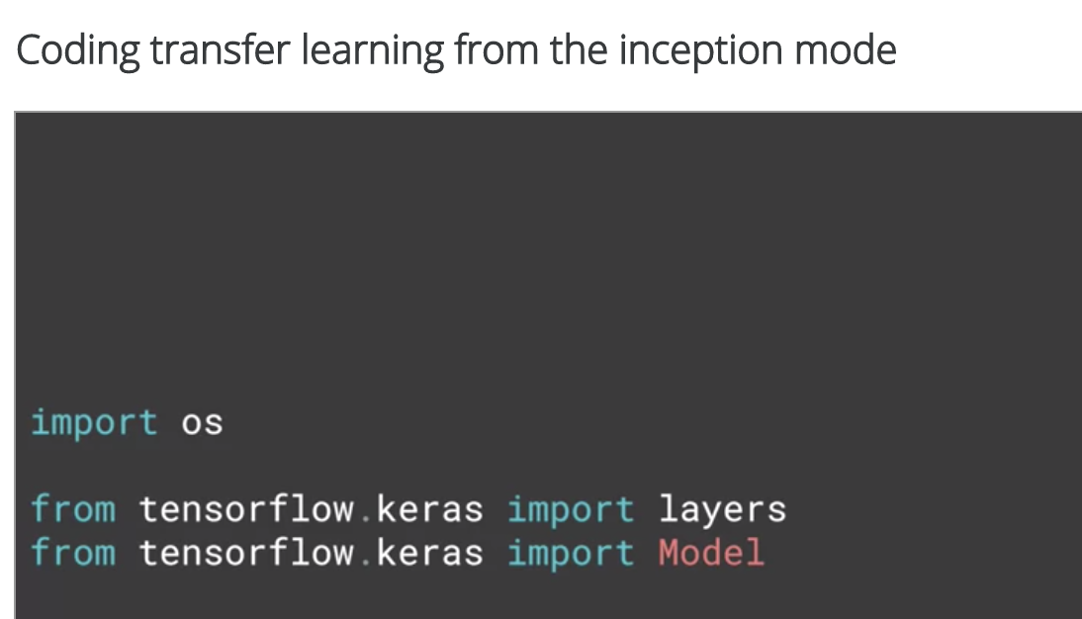

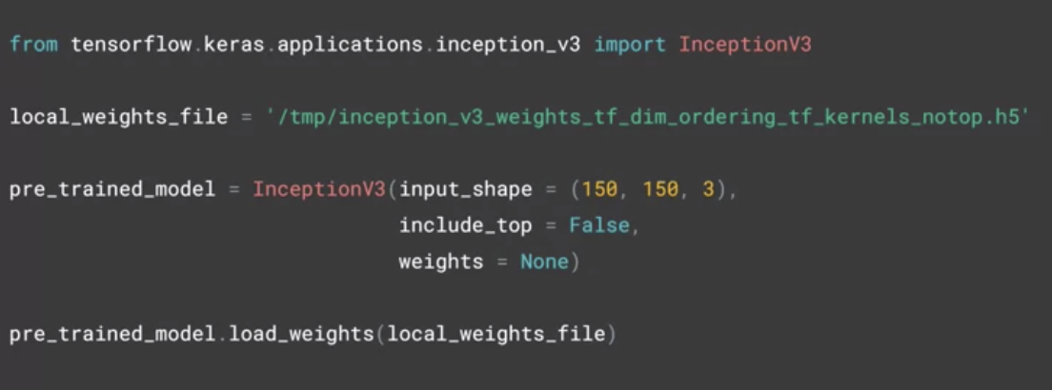

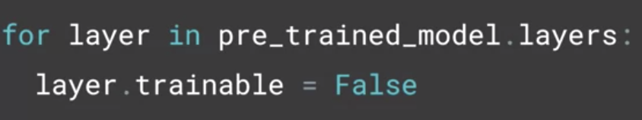

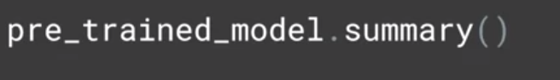

Coding own model with transferred features

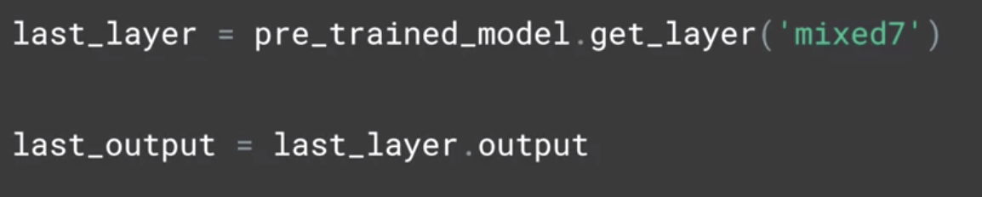

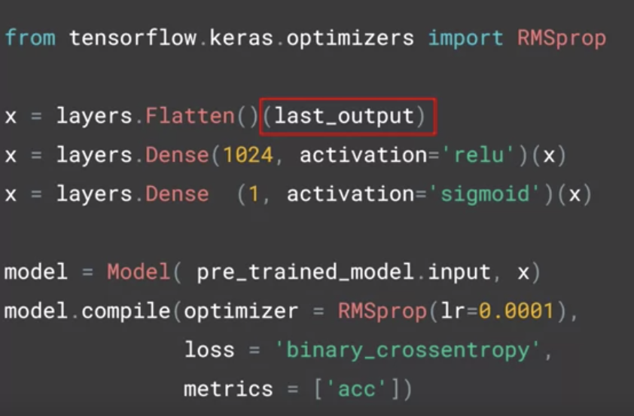

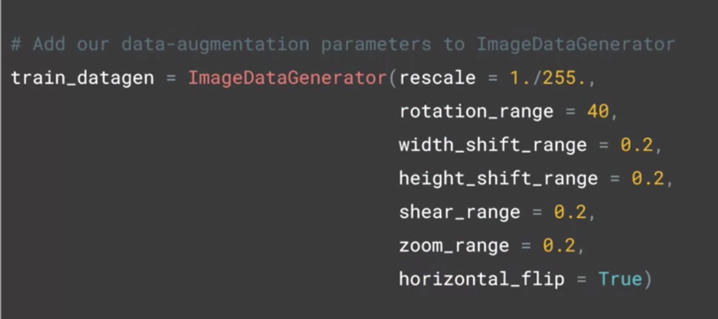

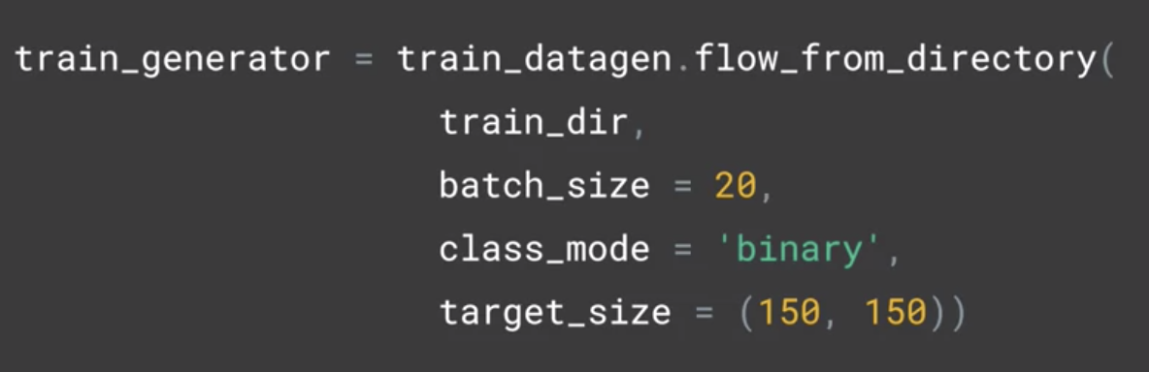

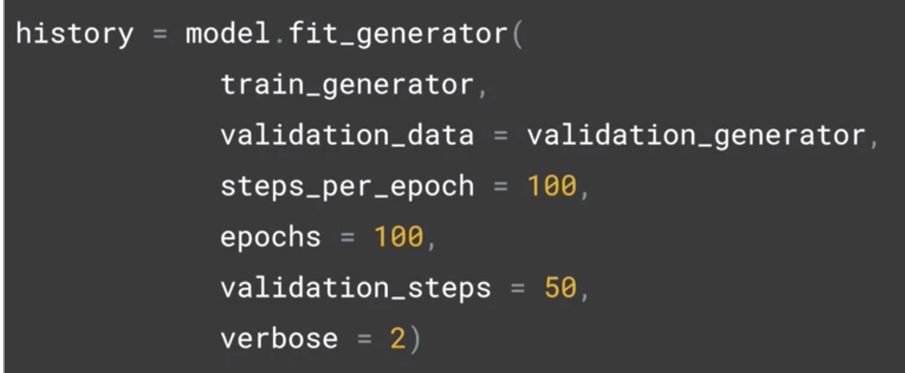

Overfitting problem

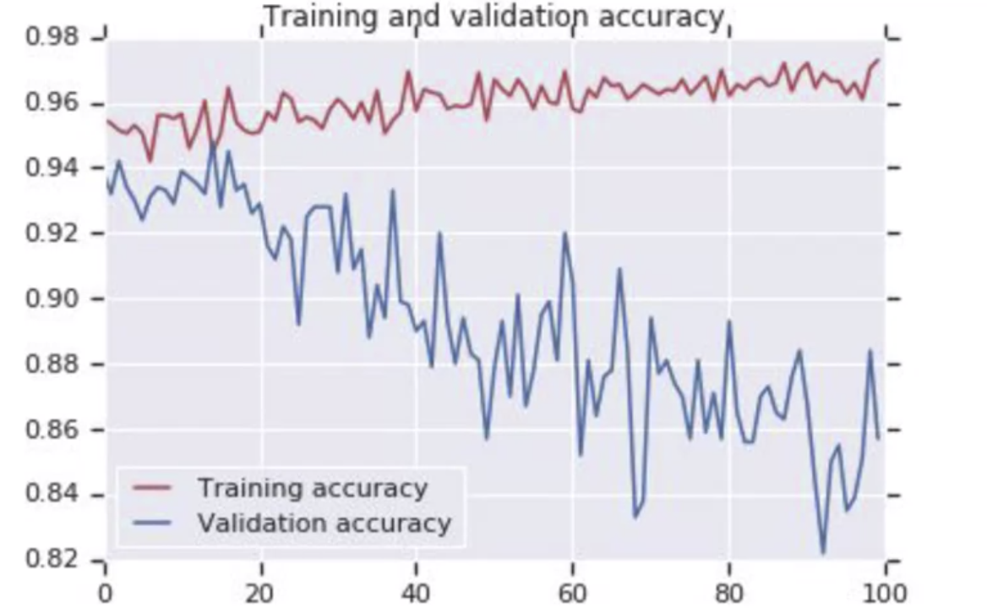

How to fix this? Use Dropout:

The idea behind Dropouts is that they remove a random number of neurons in your neural network. This works very well for two reasons: The first is that neighboring neurons often end up with similar weights, which can lead to overfitting, so dropping some out at random can remove this. The second is that often a neuron can over-weigh the input from a neuron in the previous layer, and can over specialize as a result. Thus, dropping out can break the neural network out of this potential bad habit!

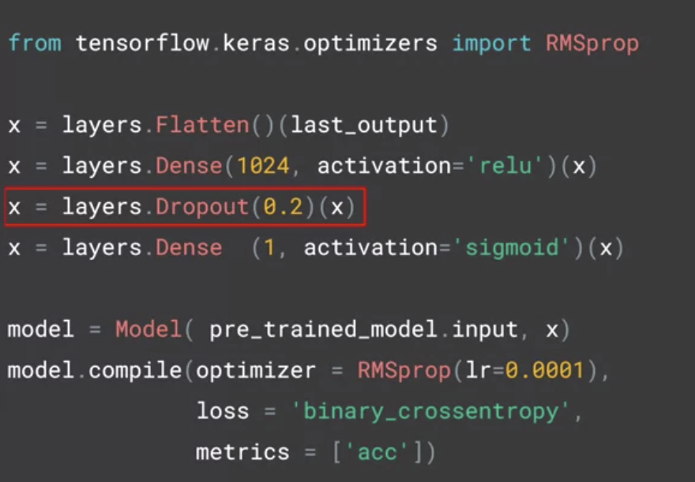

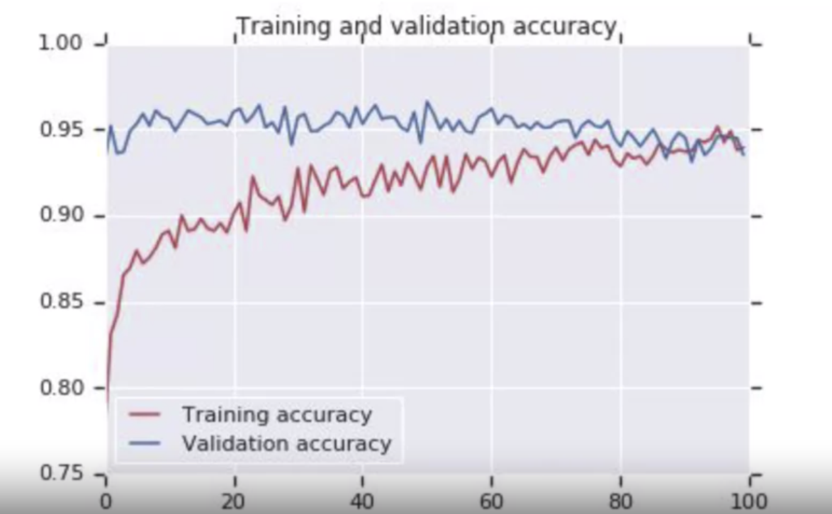

WEEK 4 – MULTICLASS CLASSIFICATIONS

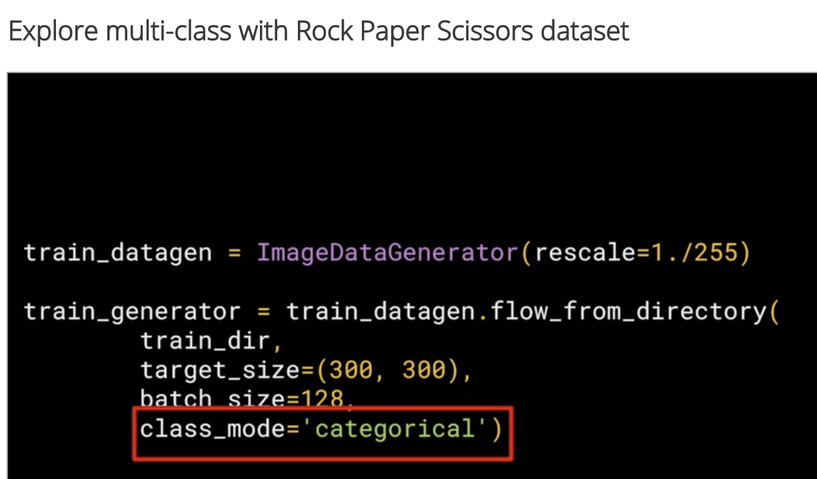

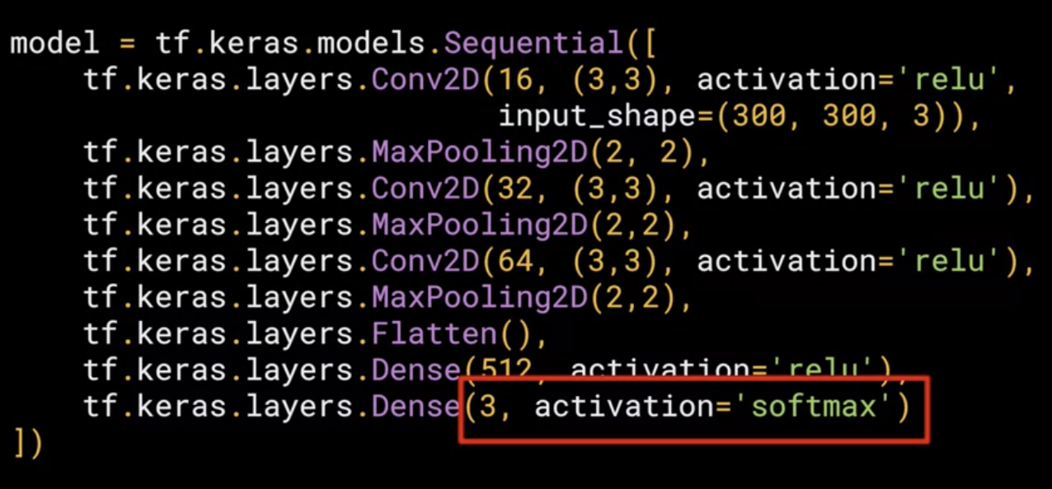

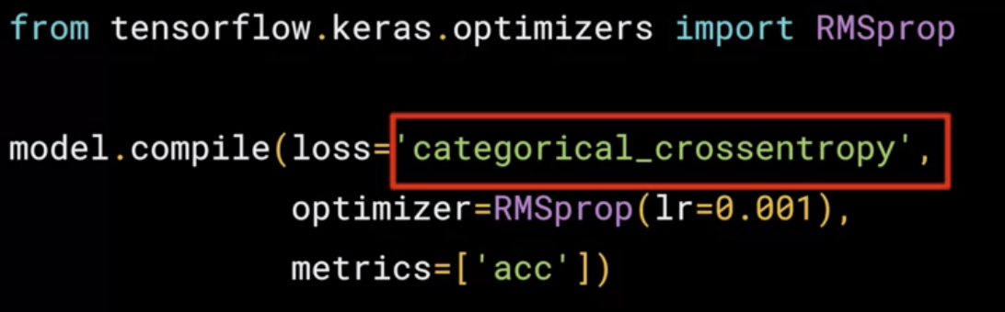

COURSE 3 – NATURAL LANGUAGE PROCESSING IN TENSORFLOW

WEEK 1 – SENTIMENT IN TEXT

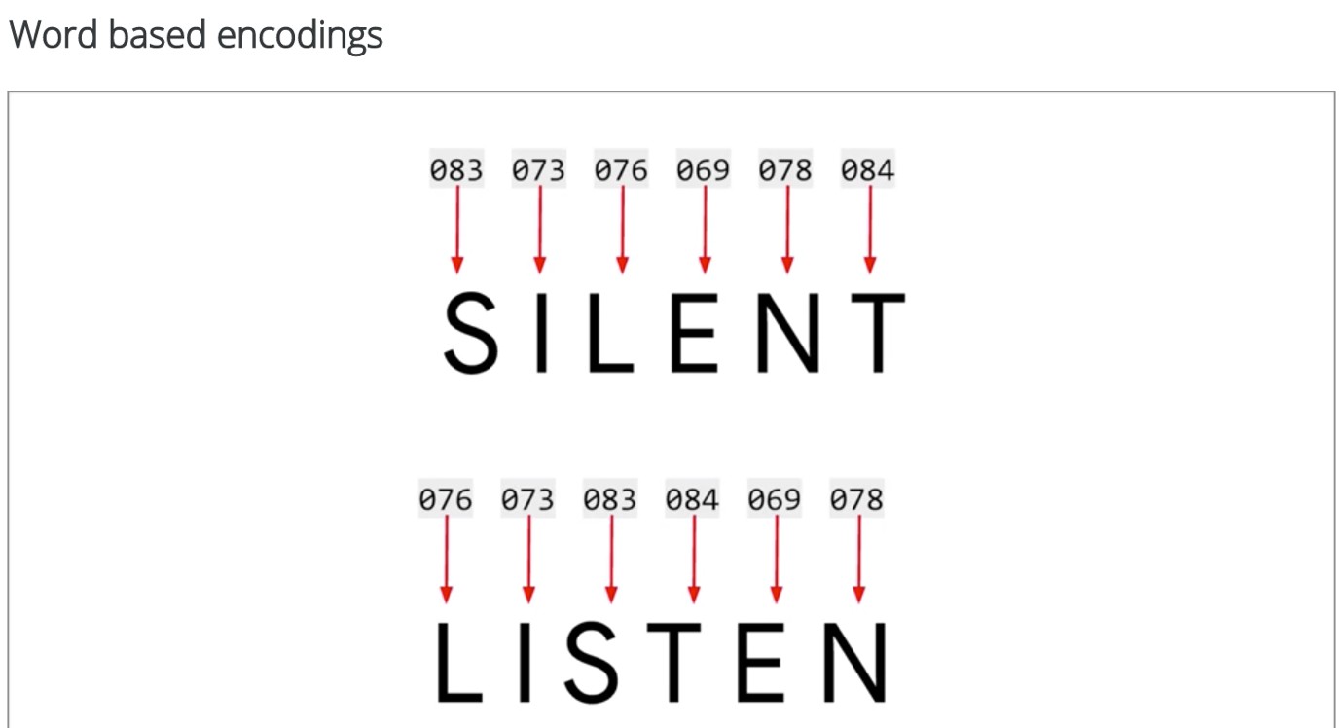

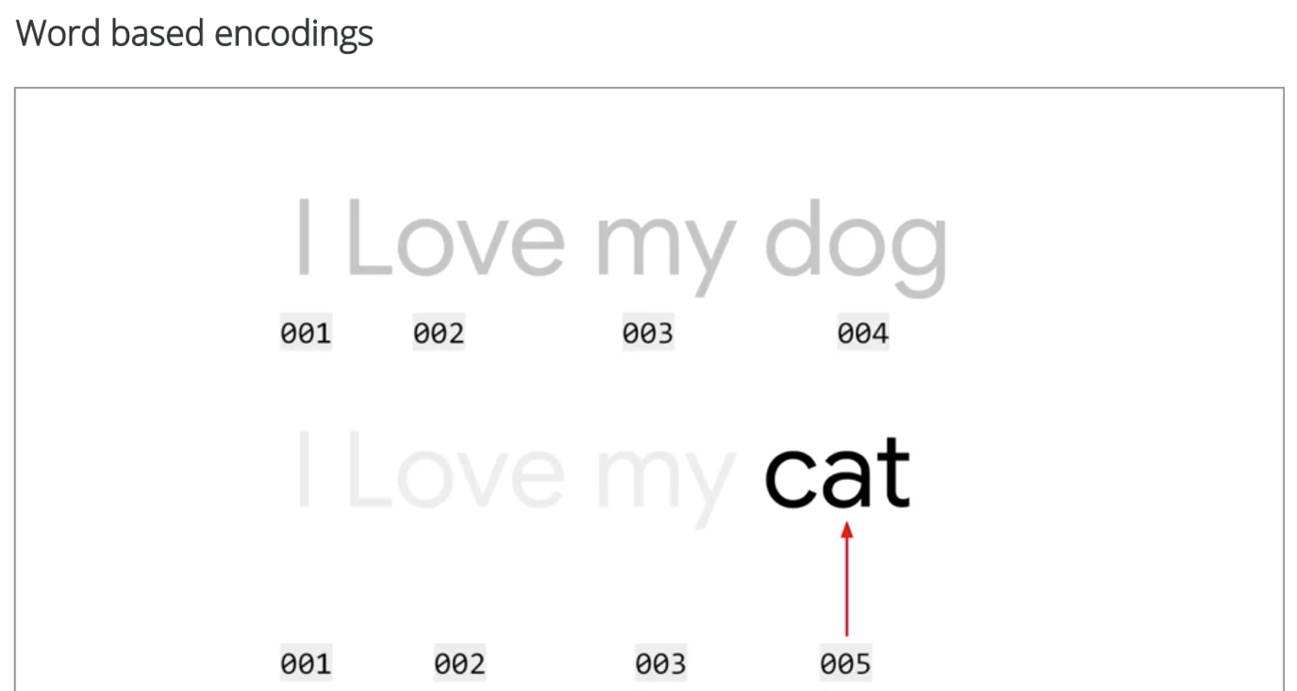

Building a dictionary of words in a sentence: Tokenizer does this: also strips punctuations out

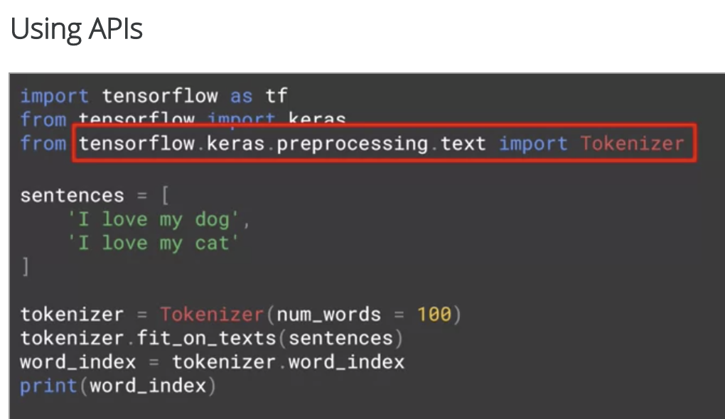



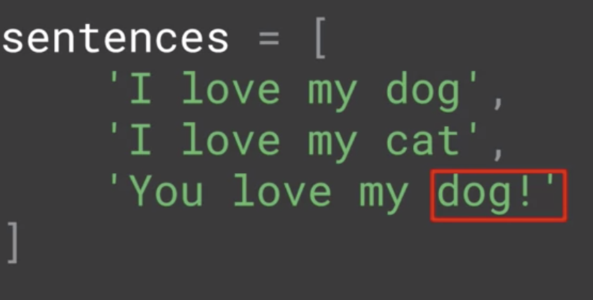

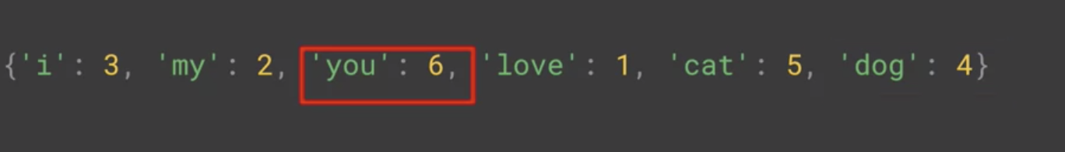

Text to Sequence

Next step: turn these sentences into a list of values based on these tokens

* Texts-to-sequences can take any set of sentences and encode them based on the word set that it learned from the one that was passed into fit_on_texts
* If you train a neural networks on a corpus of text, and the text has the word_index generated on it, then when you want to do inference with the training model, you’ll have to encode that text that you want to infer on it with the same word-index

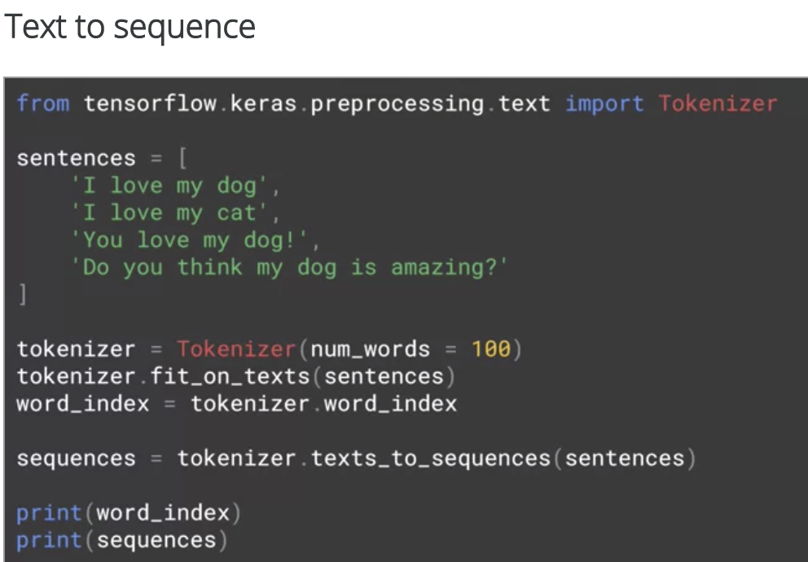

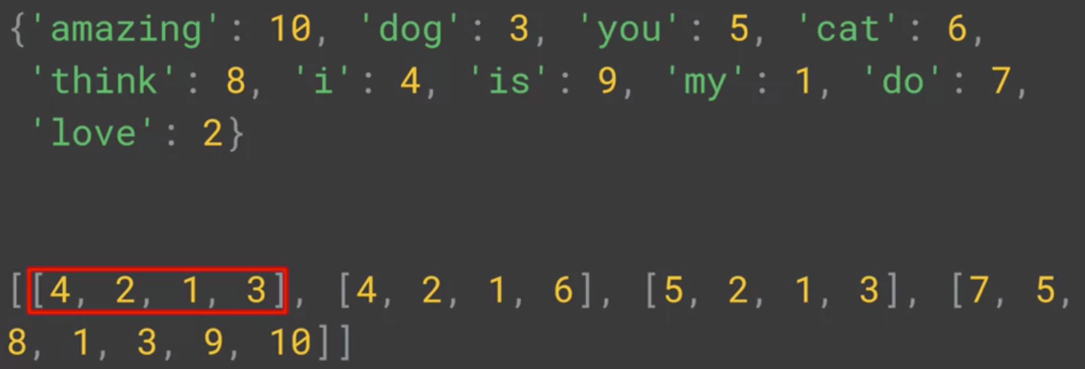

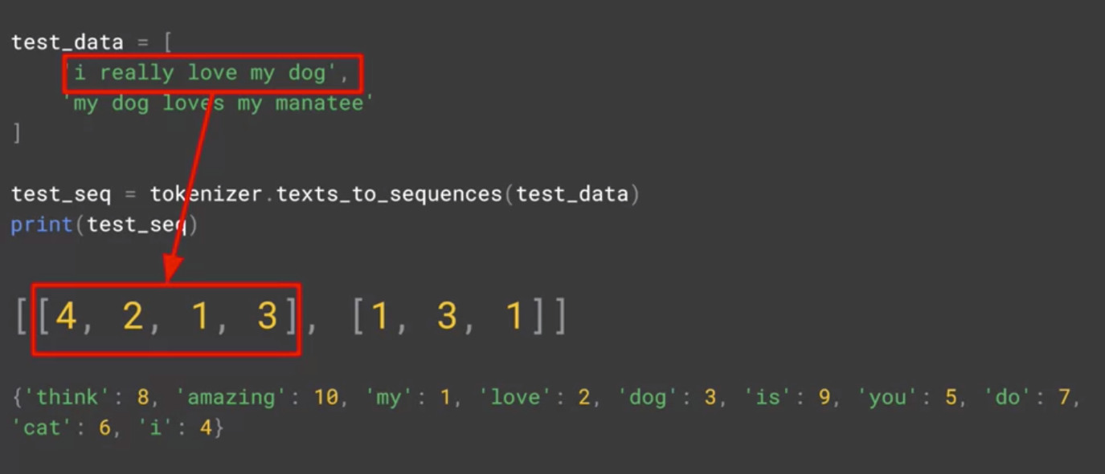

For special characters, have a special token to record them, something unique and distinct that isn’t confused with a real word

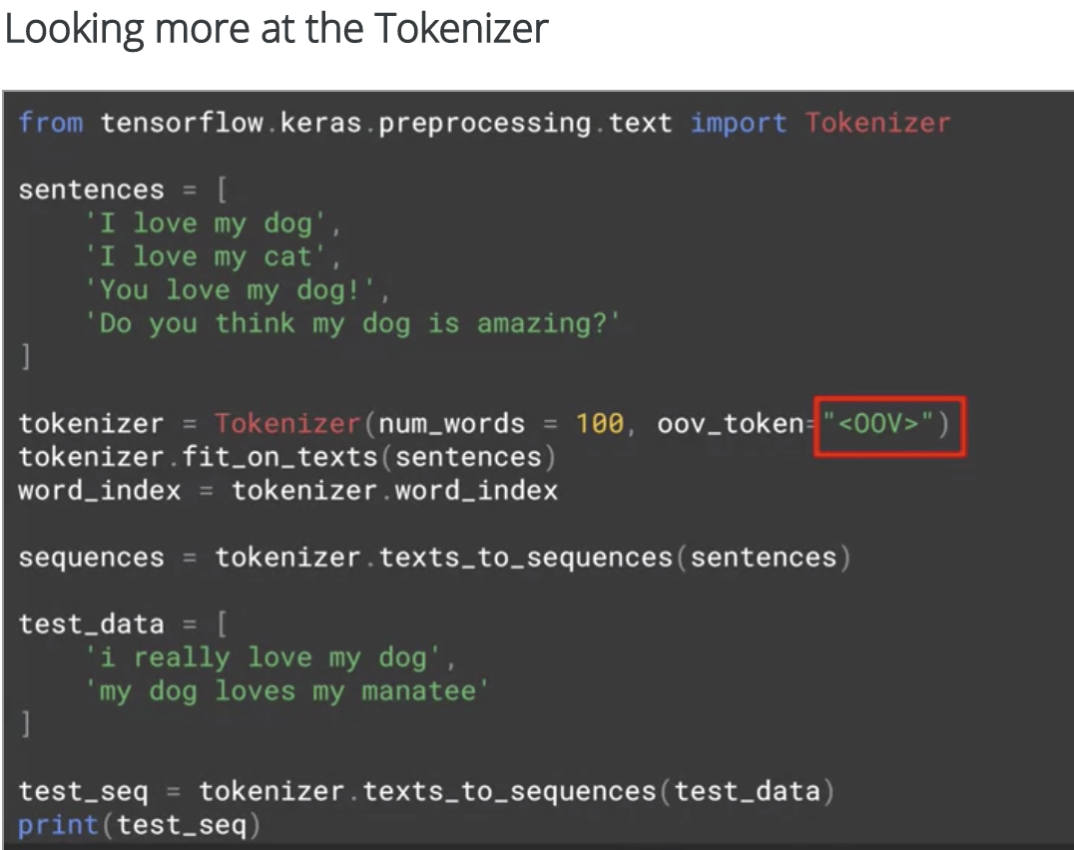

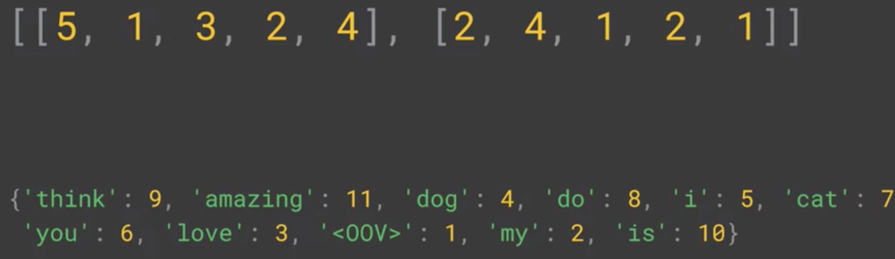

Before training, we need a level of uniformity of size => use padding

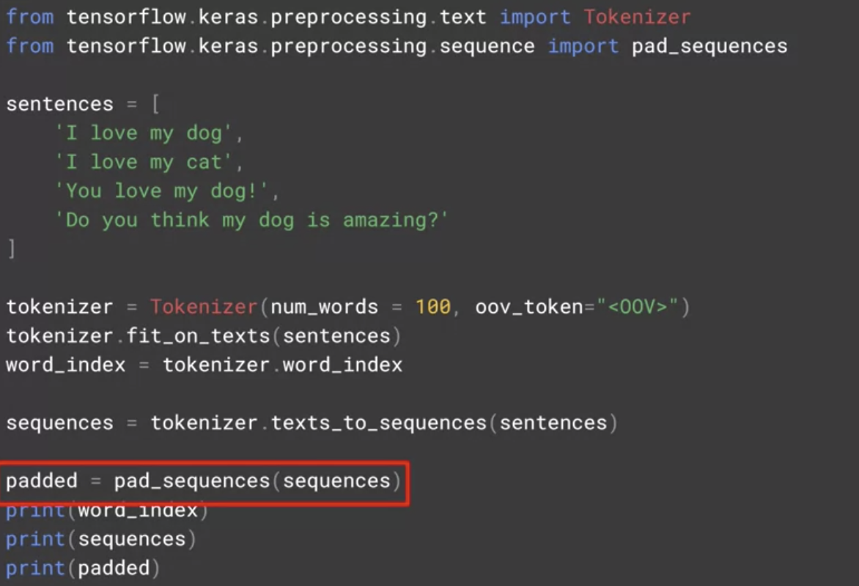

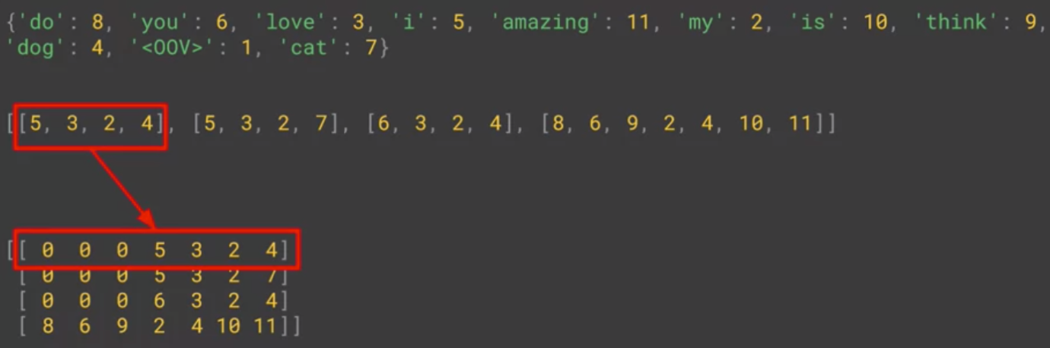



Load json can create python data structure from it =>get headlines of onion articles

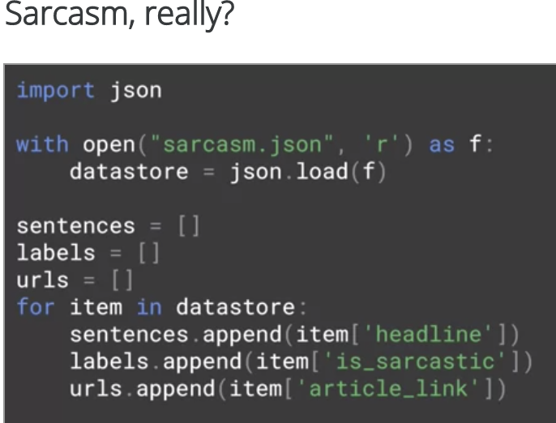

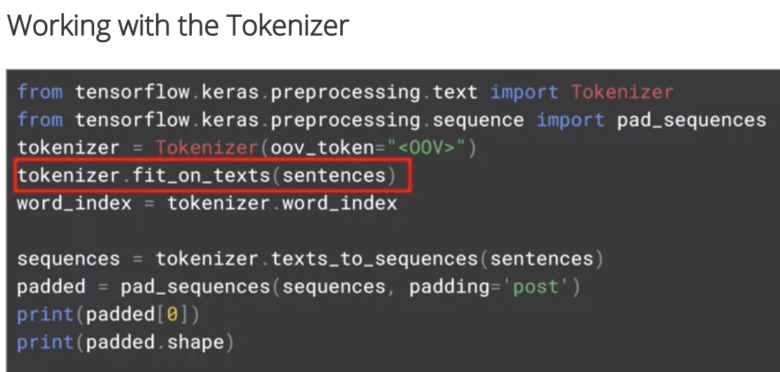

Sample of word_index and padding for sarcasm dataset:

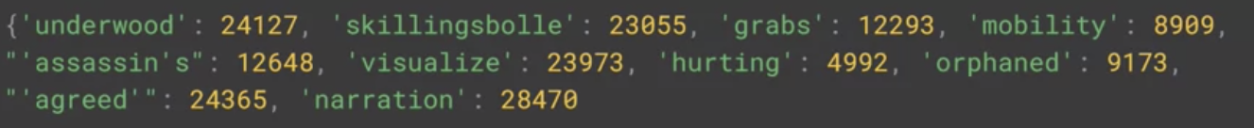

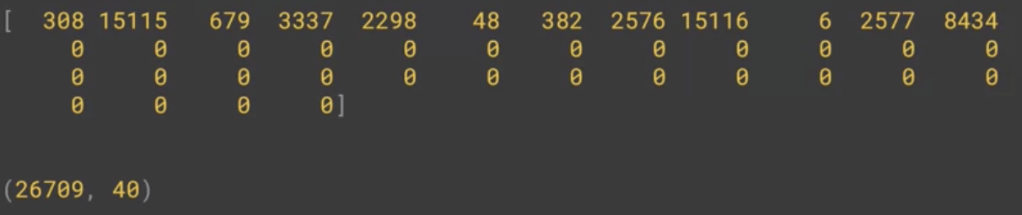

Week 1: Use tokenize to turn sentences and words into numbers, and using a dictionary to look up which word goes with which numbers

Week 2: Use Embeddings to learn the sentiments from that dictionary of words and numbers.

WEEK 2: WORD EMBEDDINGS

COURSE 4:

SEQUENCE, TIME SERIES AND PREDICTION

WEEK 1: Sequence and Predictions

Usage of ML:

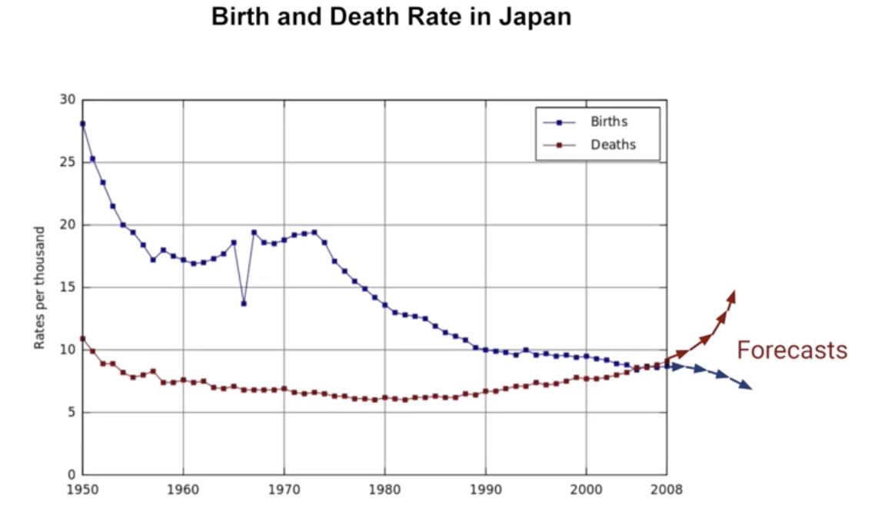

Project back into the past to see how we get to where we are today:

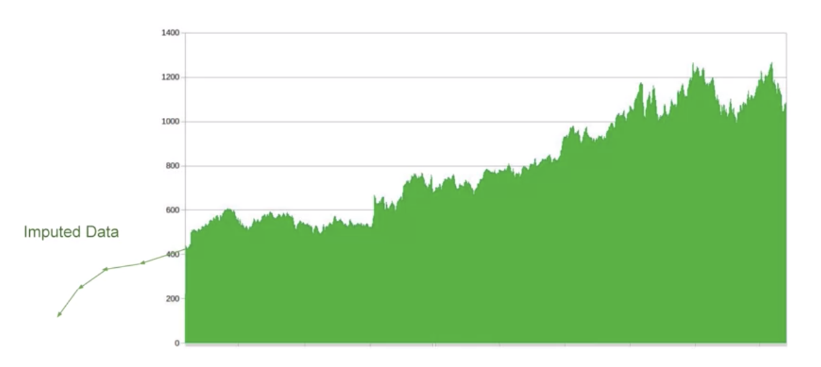

Fill in holes in data

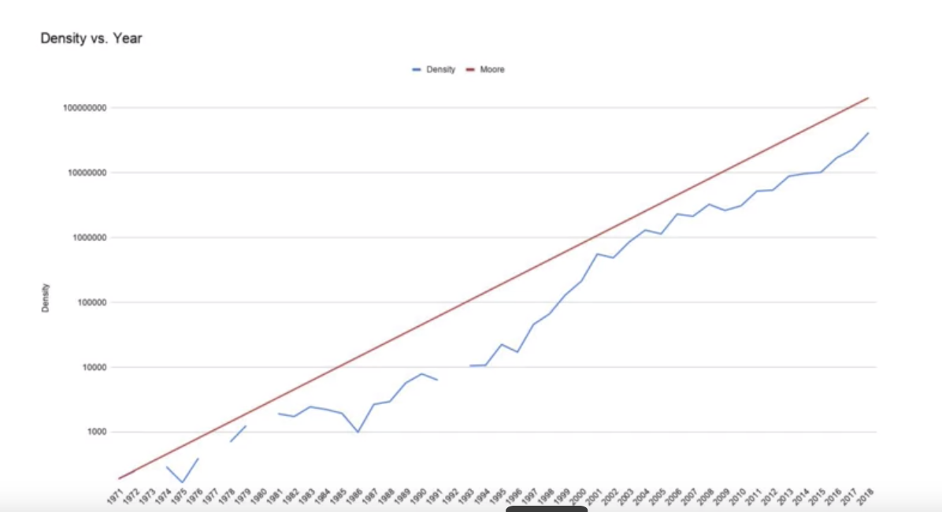

Detect anomaly: detect potential attack from website log

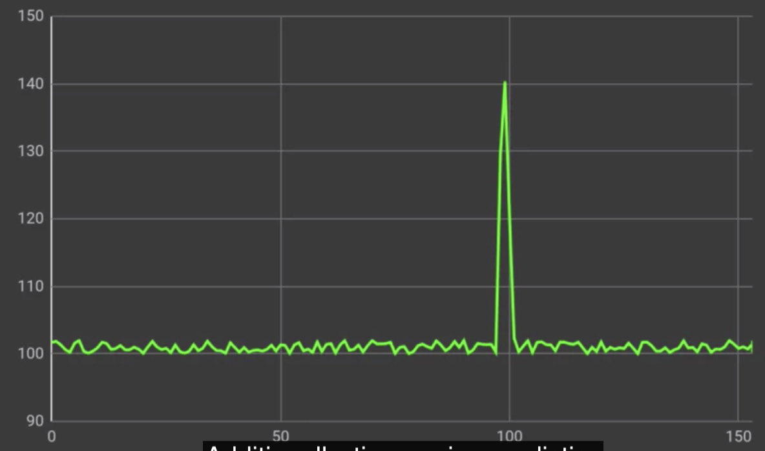

Spot patterns to recognize what generated the time-series



Common patterns in time series:

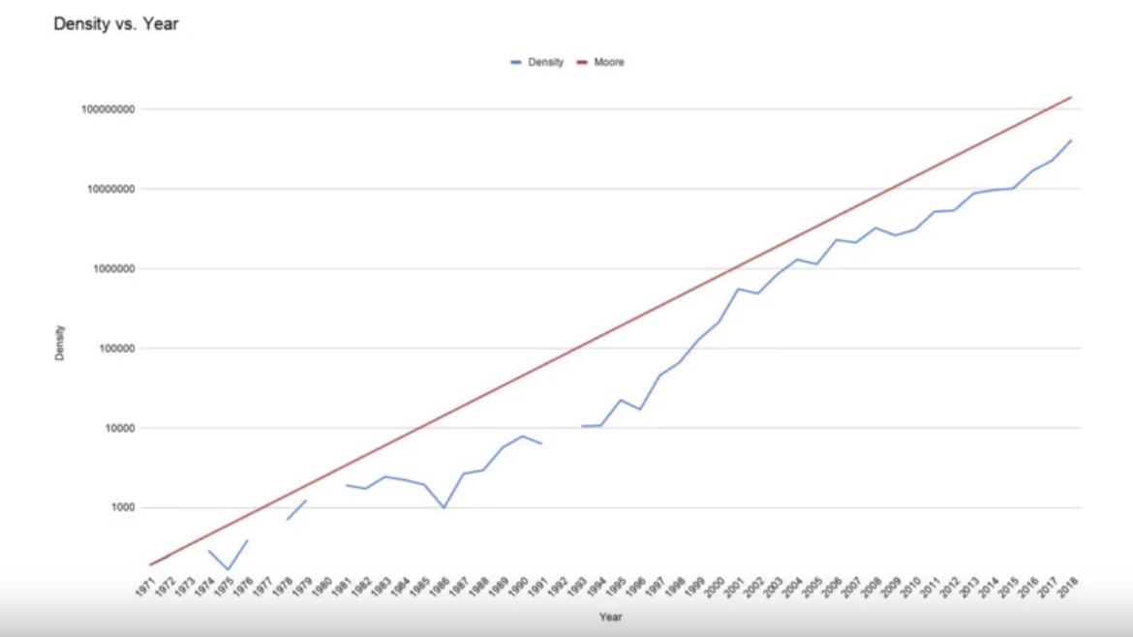

Seasonality: patterns repeat at predictable intervals

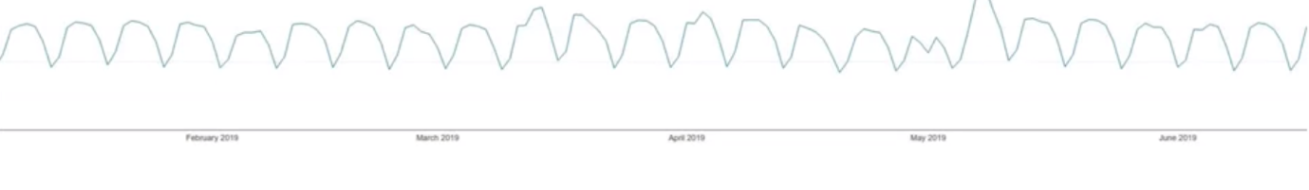

Combination of both trends and seasonality

* Overall upward trends, but there are peaks and troughs



Random

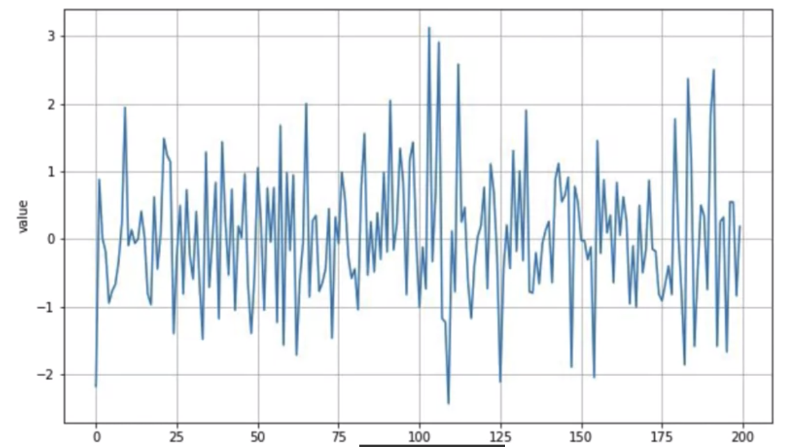

Autocorrelation: no trend, no seasonality, can’t predict easily but clearly the entire series is not random, there’s a deterministic type of decay :

* The value of each time step is 99% value of the previous time step, with some random spikes
* It correlates with a late copy of itself (a lag)
* The first lag: strong autocorrelation => having memory => a step dependent on previous one. The spike (often unpredictable) are called innovation = cannot be predicted based on past values





Another case of autocorrelation:

* Lag 1: short-term exponential decay



Real life time series will have everything:

* Machine learning helps to spot patterns => make predictions , expect for the noise which is unpredictable
* We should assume that there is a pattern that existed in the past, which will continue on into the future



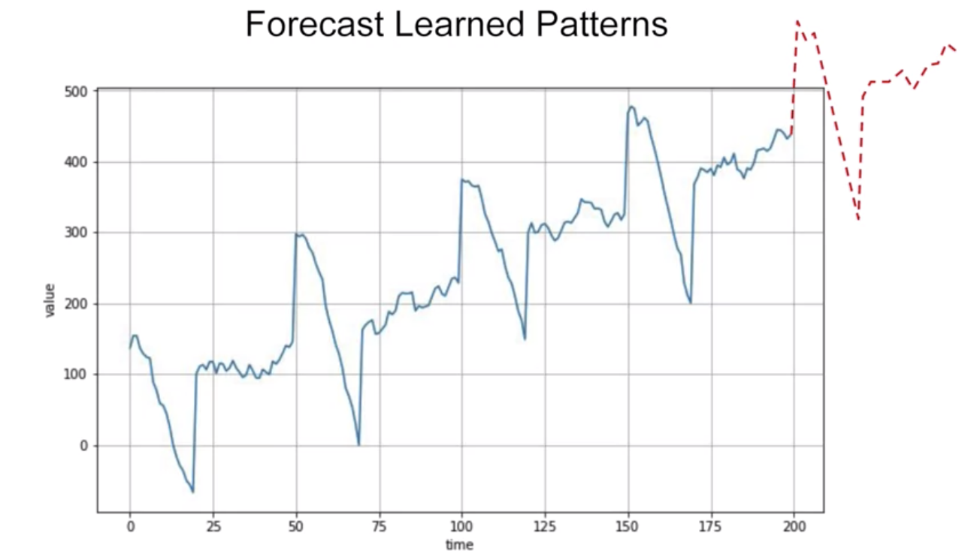

Non-stationary time series:

* Real life time series behaviour can change drastically over time => can predict by training for a short period of time => might get better performance than training on the entire time series (breaking the mold on ML since usually more data is better => but for time series, it depends on the time series itself)
* If it’s stationary (behaviour not change over time) => great
* If it’s non-stationary, the optimal training window should vary
* Ideally, we would like to take the whole series into account, but life ain’t so easy

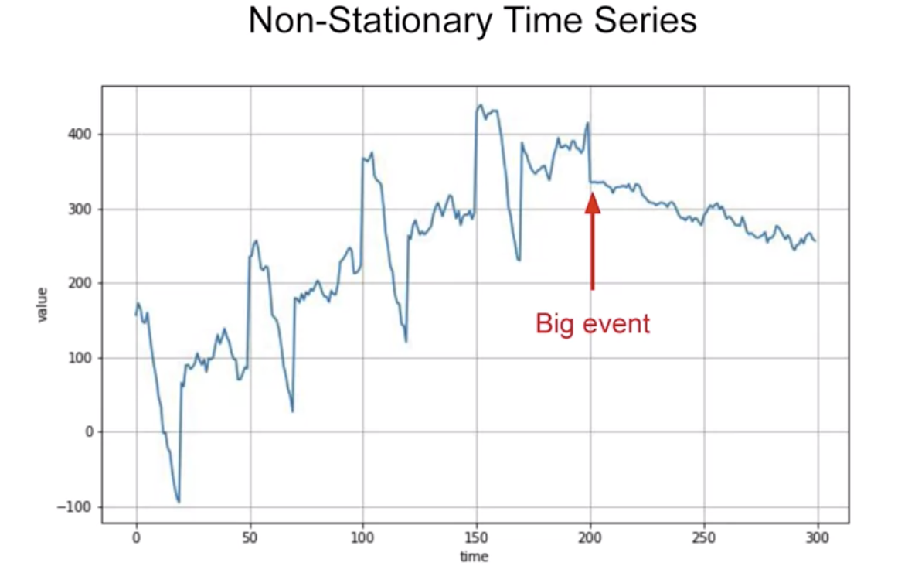

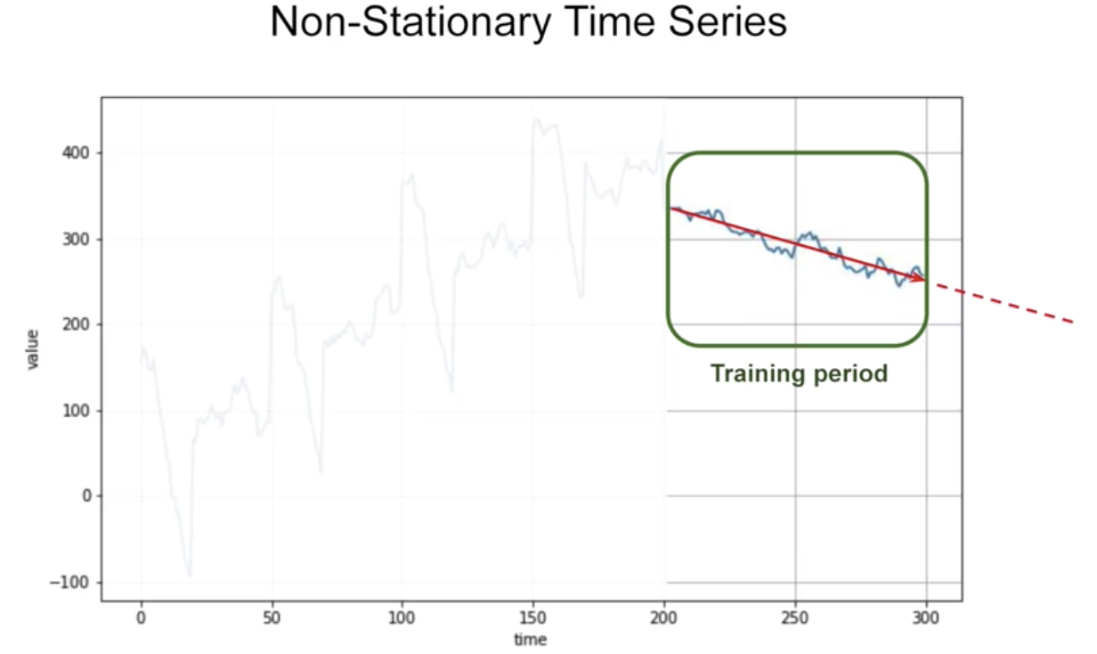

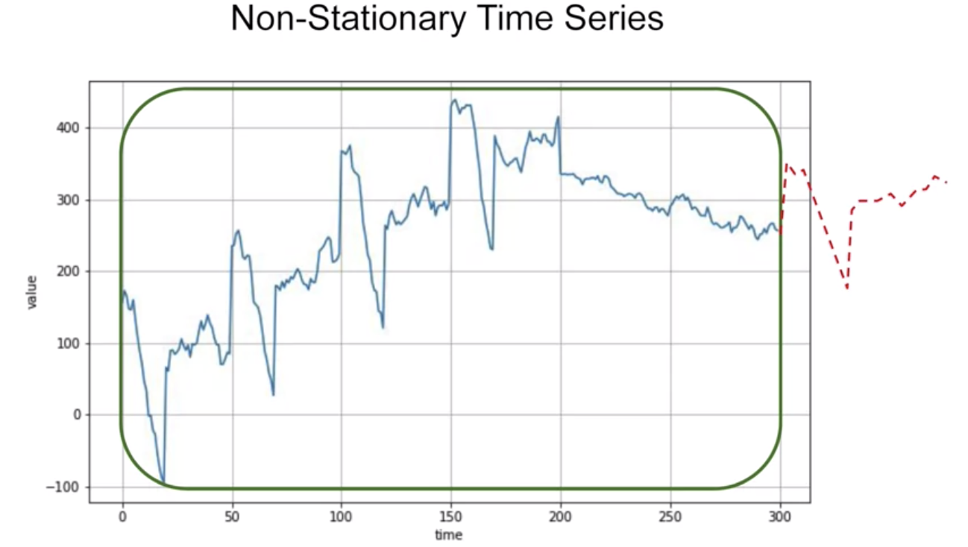

Train, validate and test

Naïve forecasting to get baseline

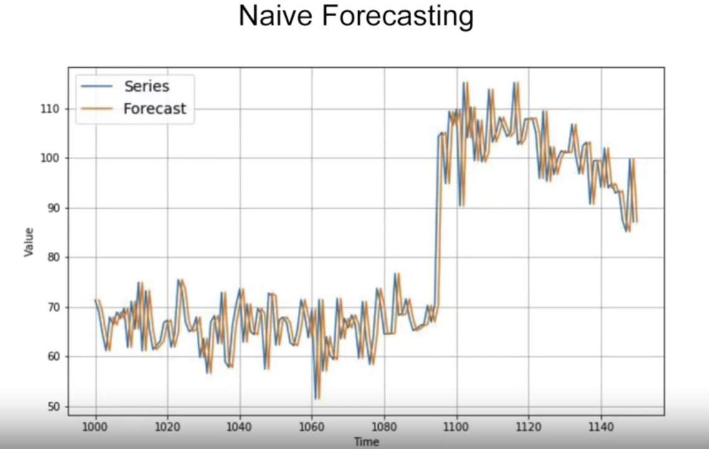

Fixed partitioning to get train, test set:

* If the time series contain seasonality, make sure to include one season in it
* Train model on training period, validate model on validation period => tune parameters with validation
* Afterwards, retrain model with both training and validation, test model on test period
* If it performs well, retrain model again using all training, validation and test data => test data is the one that is closest to the data point you have in time => strongest signal in determining future values

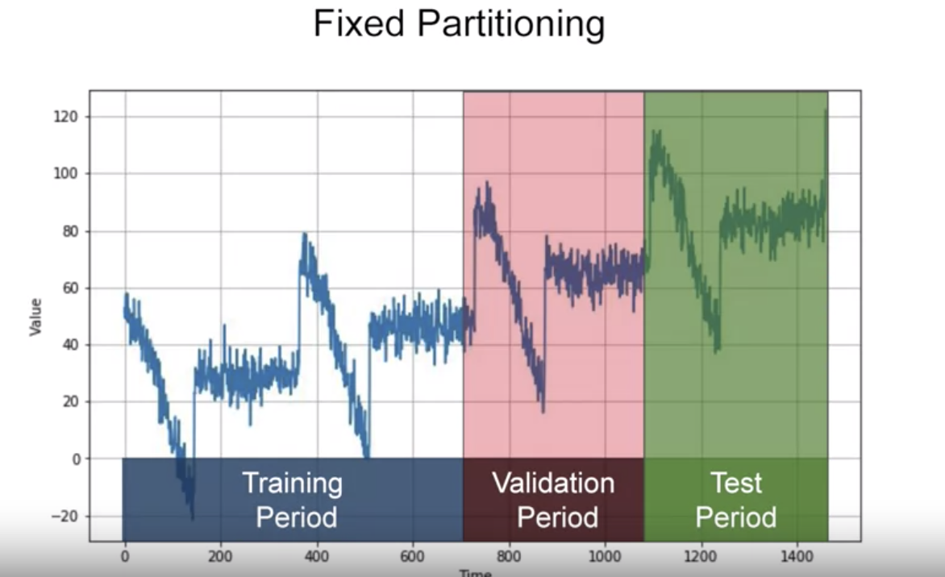



Roll forward Partitioning:

* We start with a short training period, and we gradually increase it, say by one day at a time, or by one week at a time. At each iteration, we train the model on a training period. And we use it to forecast the following day, or the following week, in the validation period. And this is called roll-forward partitioning. You could see it as doing fixed partitioning a number of times, and then continually refining the model as such. For the purposes of learning time series prediction in this course, will learn the overall code for doing series prediction. Which you could then apply yourself to a roll-forward scenario, but our focus is going to be on fixed partitioning.



Metrics for evaluating performance:

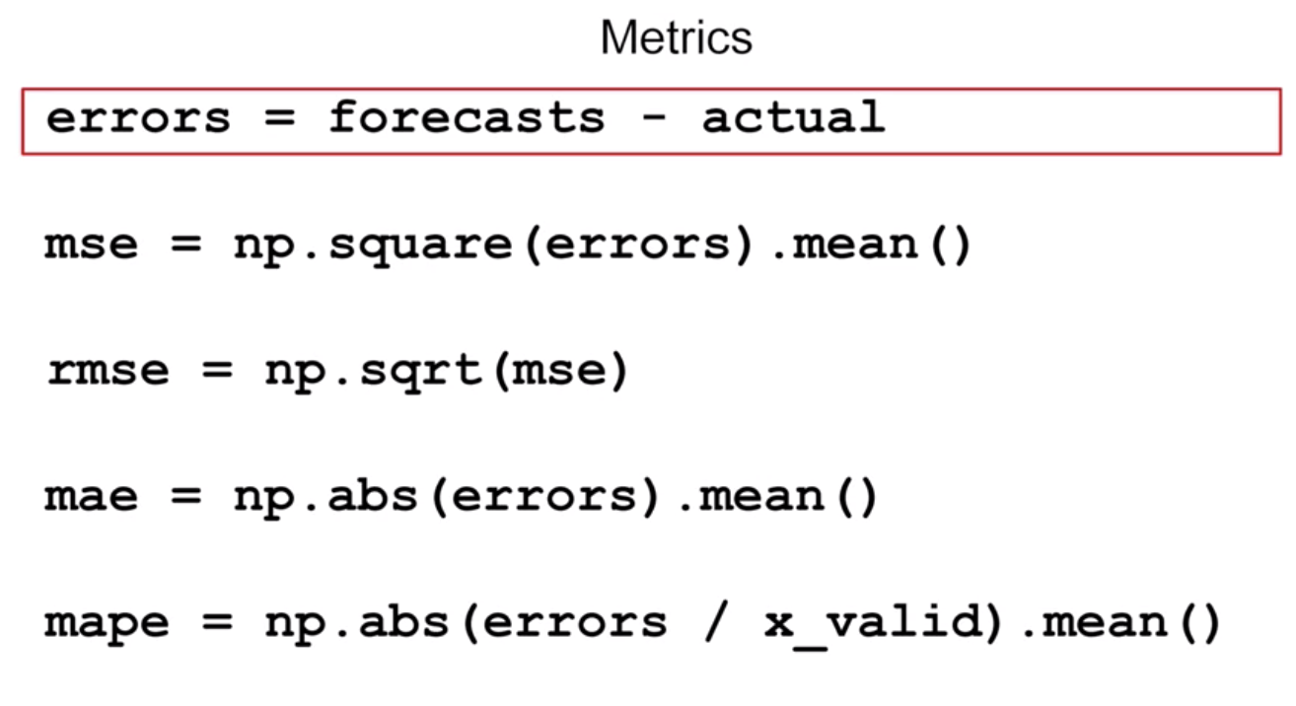

The most common metric to evaluate the forecasting performance of a model is the mean squared error or mse where we square the errors and then calculate their mean. Well, why would we square it? Well, the reason for this is to get rid of negative values. So, for example, if our error was two above the value, then it will be two, but if it were two below the value, then it will be minus two. These errors could then effectively cancel each other out, which will be wrong because we have two errors and not none. But if we square the error of value before analyzing, then both of these errors would square to four, not canceling each other out and effectively being equal.

And if we want the mean of our errors' calculation to be of the same scale as the original errors, then we just get its square root, giving us a root means squared error or rmse. Another common metric and one of my favorites is the mean absolute error or mae, and it's also called the main absolute deviation or mad. And in this case, instead of squaring to get rid of negatives, it just uses their absolute value. This does not penalize large errors as much as the mse does.

Depending on your task, you may prefer the mae or the mse. For example, if large errors are potentially dangerous and they cost you much more than smaller errors, then you may prefer the mse. But if your gain or your loss is just proportional to the size of the error, then the mae may be better. Also, you can measure the mean absolute percentage error or mape, this is the mean ratio between the absolute error and the absolute value, this gives an idea of the size of the errors compared to the values.



Moving average

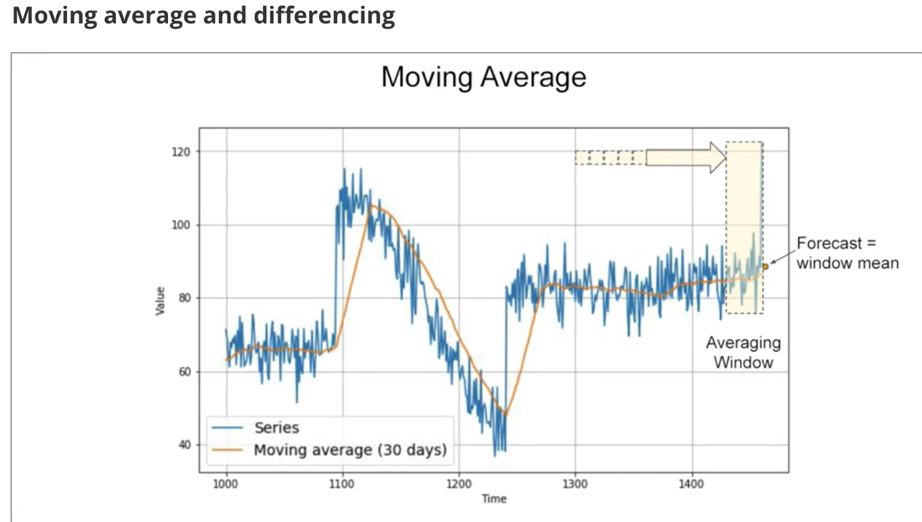







A common and very simple forecasting method is to calculate a moving average. The idea here is that the yellow line is a plot of the average of the blue values over a fixed period called an averaging window, for example, 30 days. Now this nicely eliminates a lot of the noise and it gives us a curve roughly emulating the original series, but it does not anticipate trend or seasonality. Depending on the current time i.e. the period after which you want to forecast for the future, it can actually end up being worse than a naive forecast. In this case, for example, I got a mean absolute error of about 7.14. One method to avoid this is to remove the trend and seasonality from the time series with a technique called differencing. So instead of studying the time series itself, we study the difference between the value at time T and the value at an earlier period. Depending on the time of your data, that period might be a year, a day, a month or whatever. Let's look at a year earlier. So for this data, at time T minus 365, we'll get this difference time series which has no trend and no seasonality. We can then use a moving average to forecast this time series which gives us these forecasts. But these are just forecasts for the difference time series, not the original time series. To get the final forecasts for the original time series, we just need to add back the value at time T minus 365, and we'll get these forecasts. They look much better, don't they? If we measure the mean absolute error on the validation period, we get about 5.8. So it's slightly better than naive forecasting but not tremendously better. You may have noticed that our moving average removed a lot of noise but our final forecasts are still pretty noisy. Where does that noise come from? Well, that's coming from the past values that we added back into our forecasts. So we can improve these forecasts by also removing the past noise using a moving average on that. If we do that, we get much smoother forecasts. In fact, this gives us a mean squared error over the validation period of just about 4.5. Now that's much better than all of the previous methods. In fact, since the series is generated, we can compute that a perfect model will give a mean absolute error of about four due to the noise. Apparently, with this approach, we're not too far from the optimal. Keep this in mind before you rush into deep learning. Simple approaches sometimes can work just fine.

**Trailing vs. centered window**

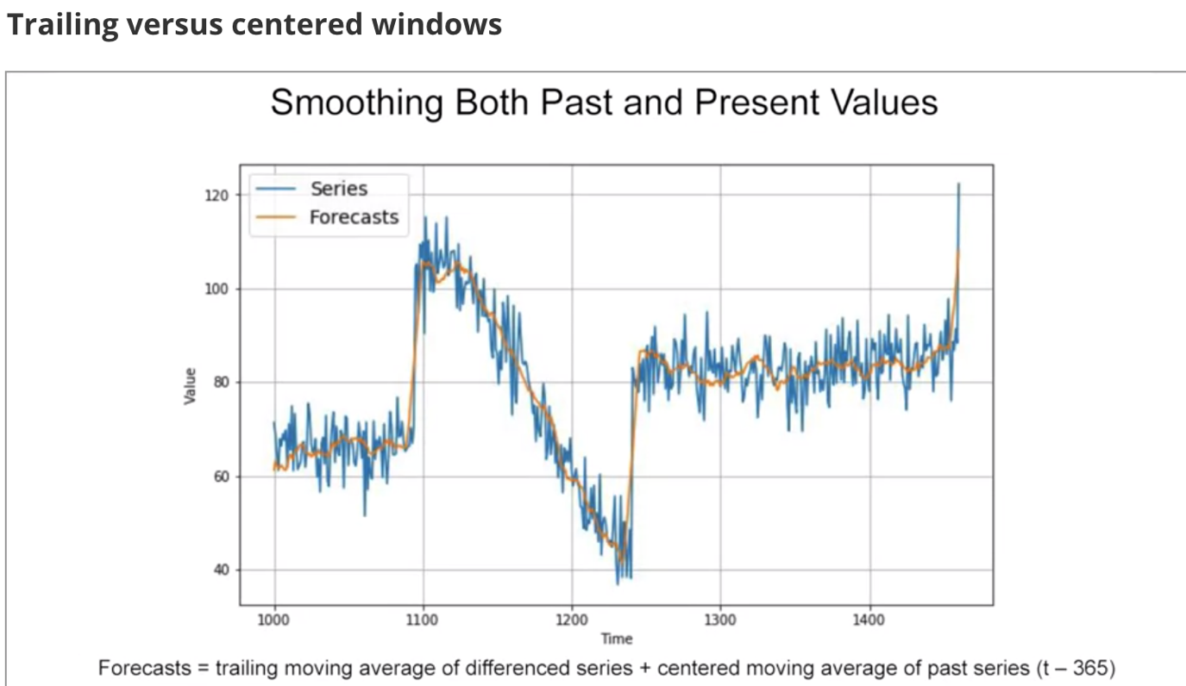

Note that when we use the trailing window when computing the moving average of present values from t minus 32, t minus one. But when we use a centered window to compute the moving average of past values from one year ago, that's t minus one year minus five days, to t minus one year plus five days. Then moving averages using centered windows can be more accurate than using trailing windows. But we can't use centered windows to smooth present values since we don't know future values. However, to smooth past values we can afford to use centered windows.